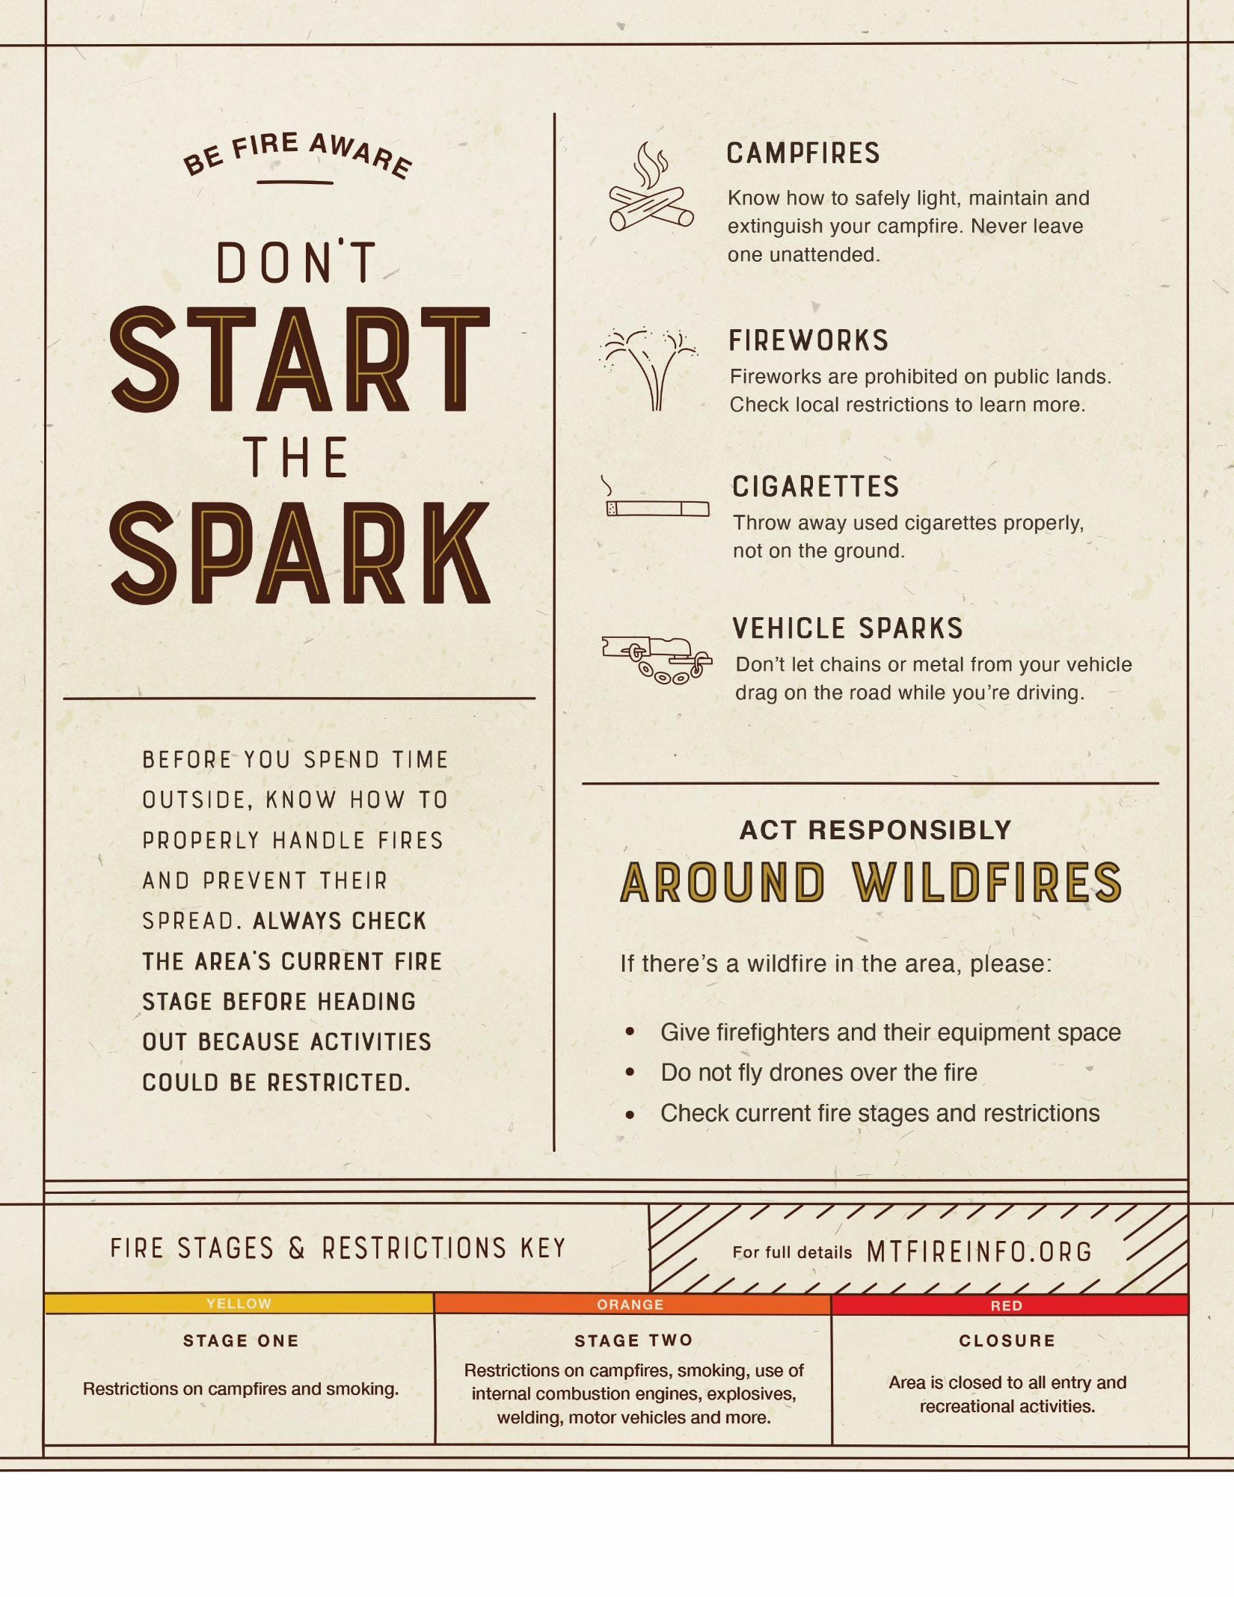

Find the latest fire details at [URL].

**INSERT PARTNER LOGO HERE**