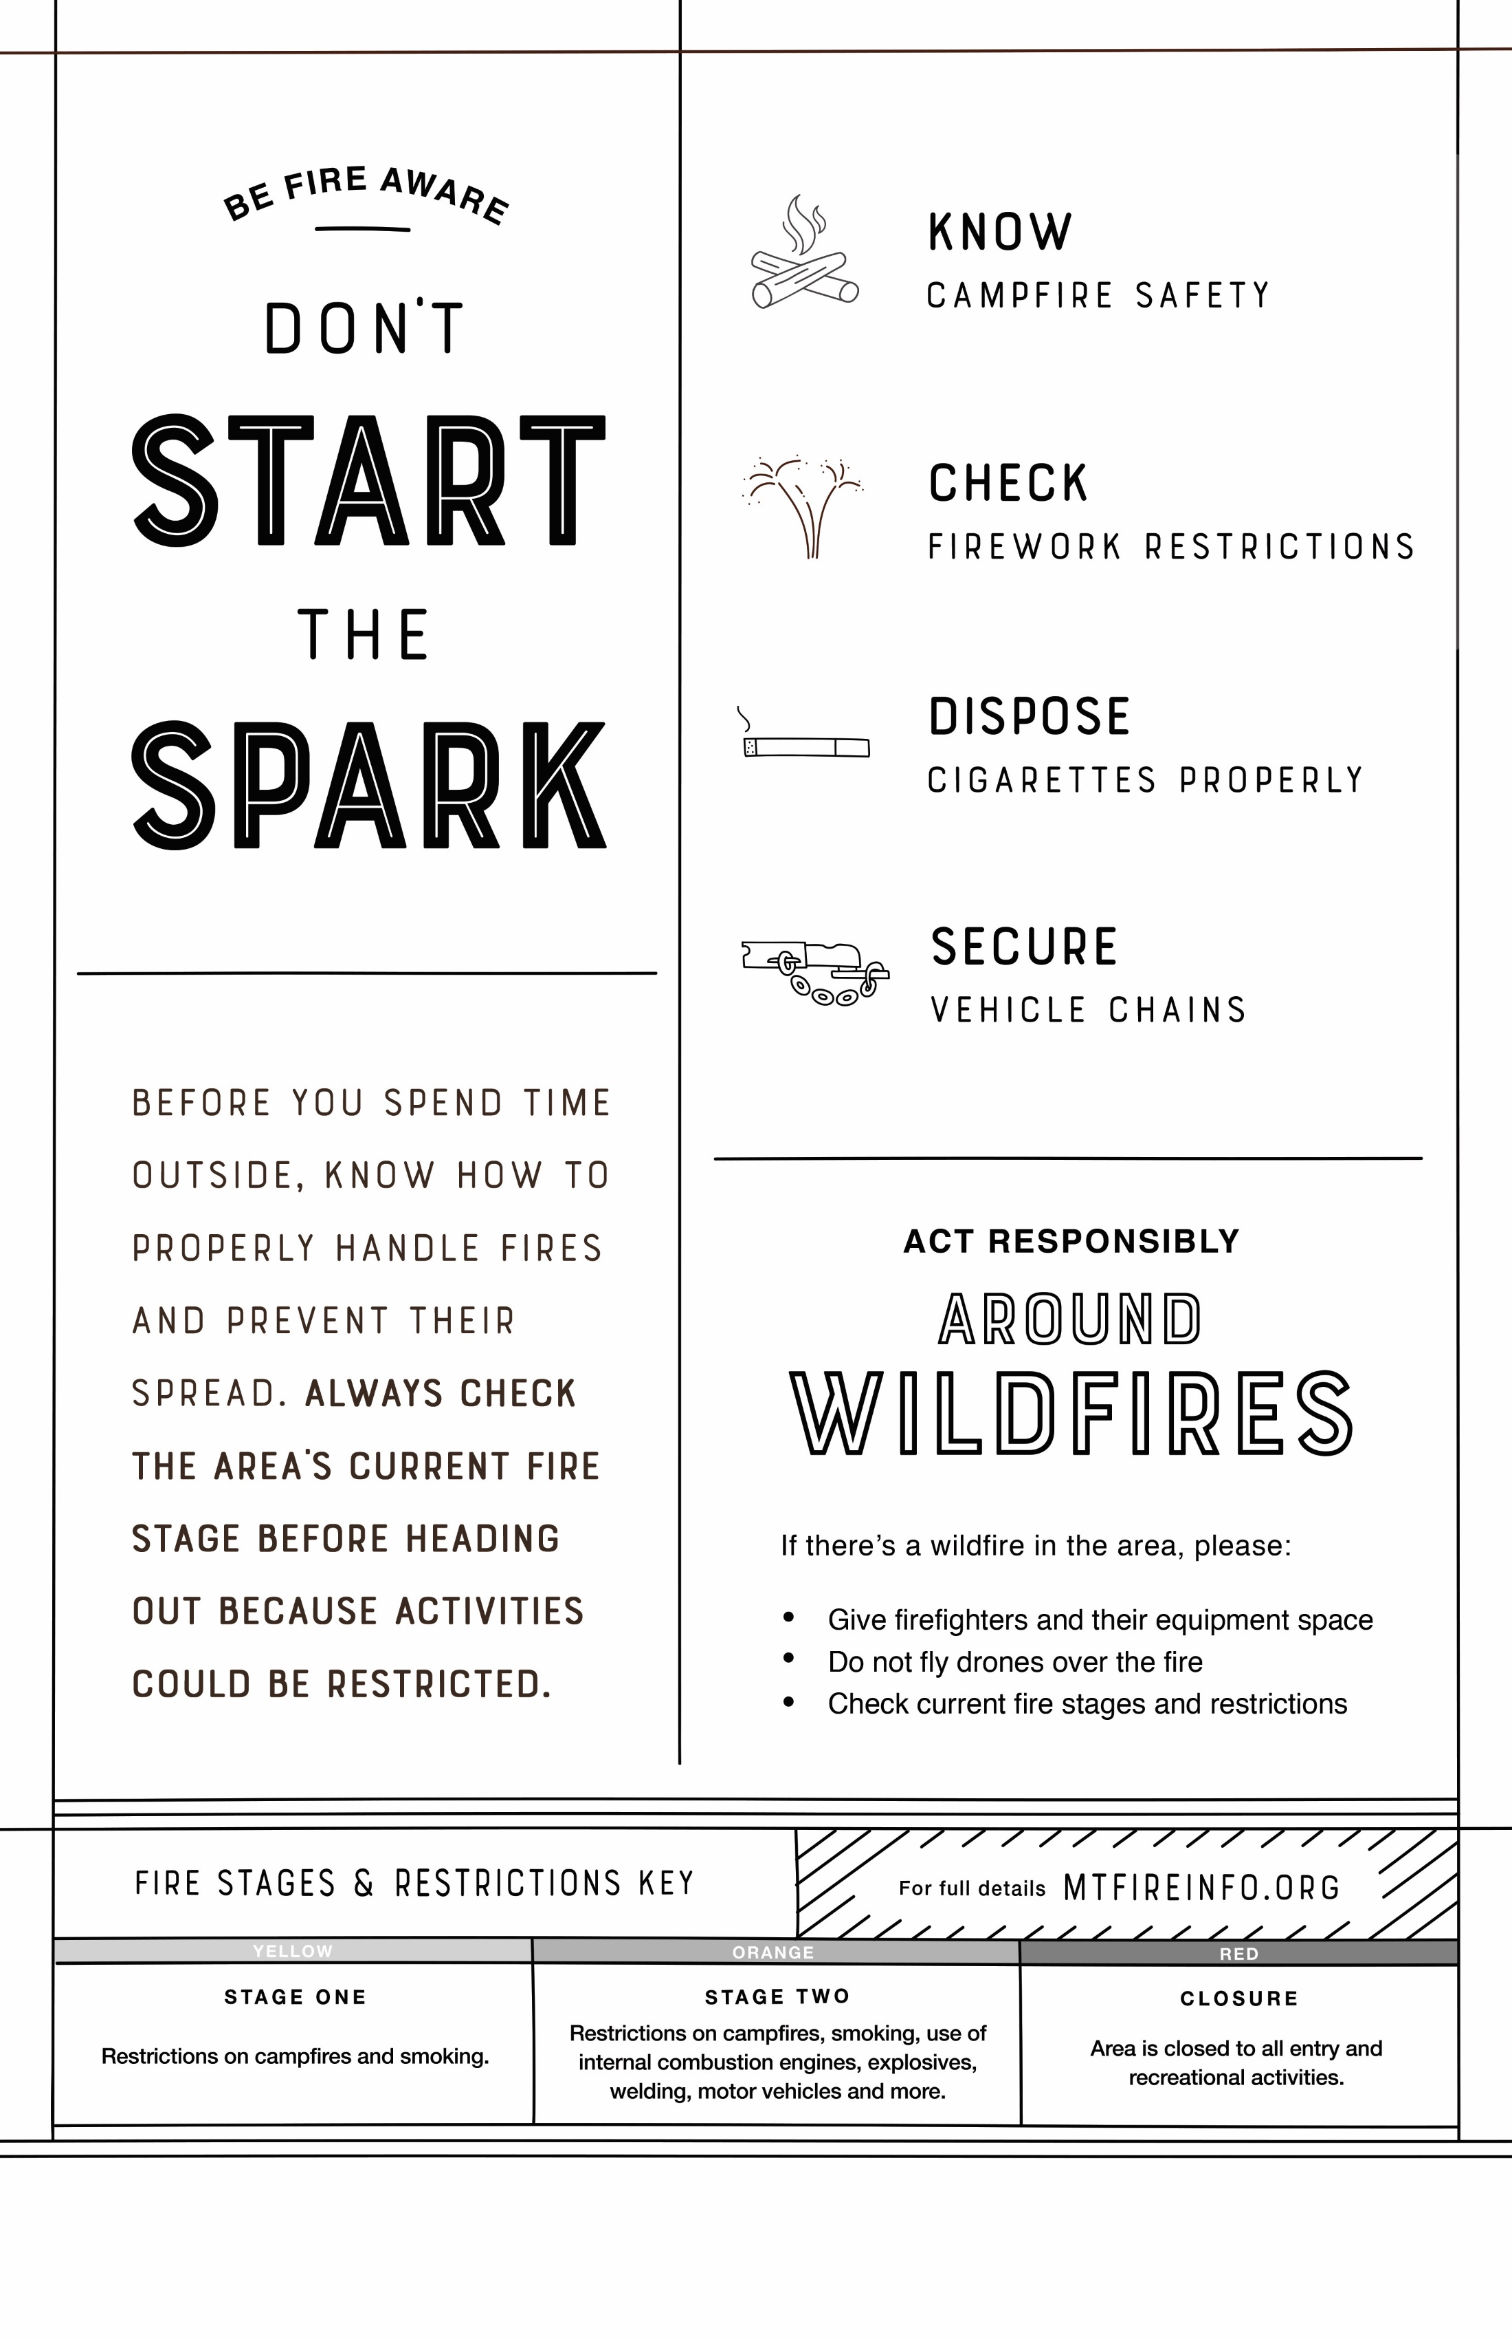

**INSERT PARTNER LOGO HERE**

Find the latest fire details at [URL].