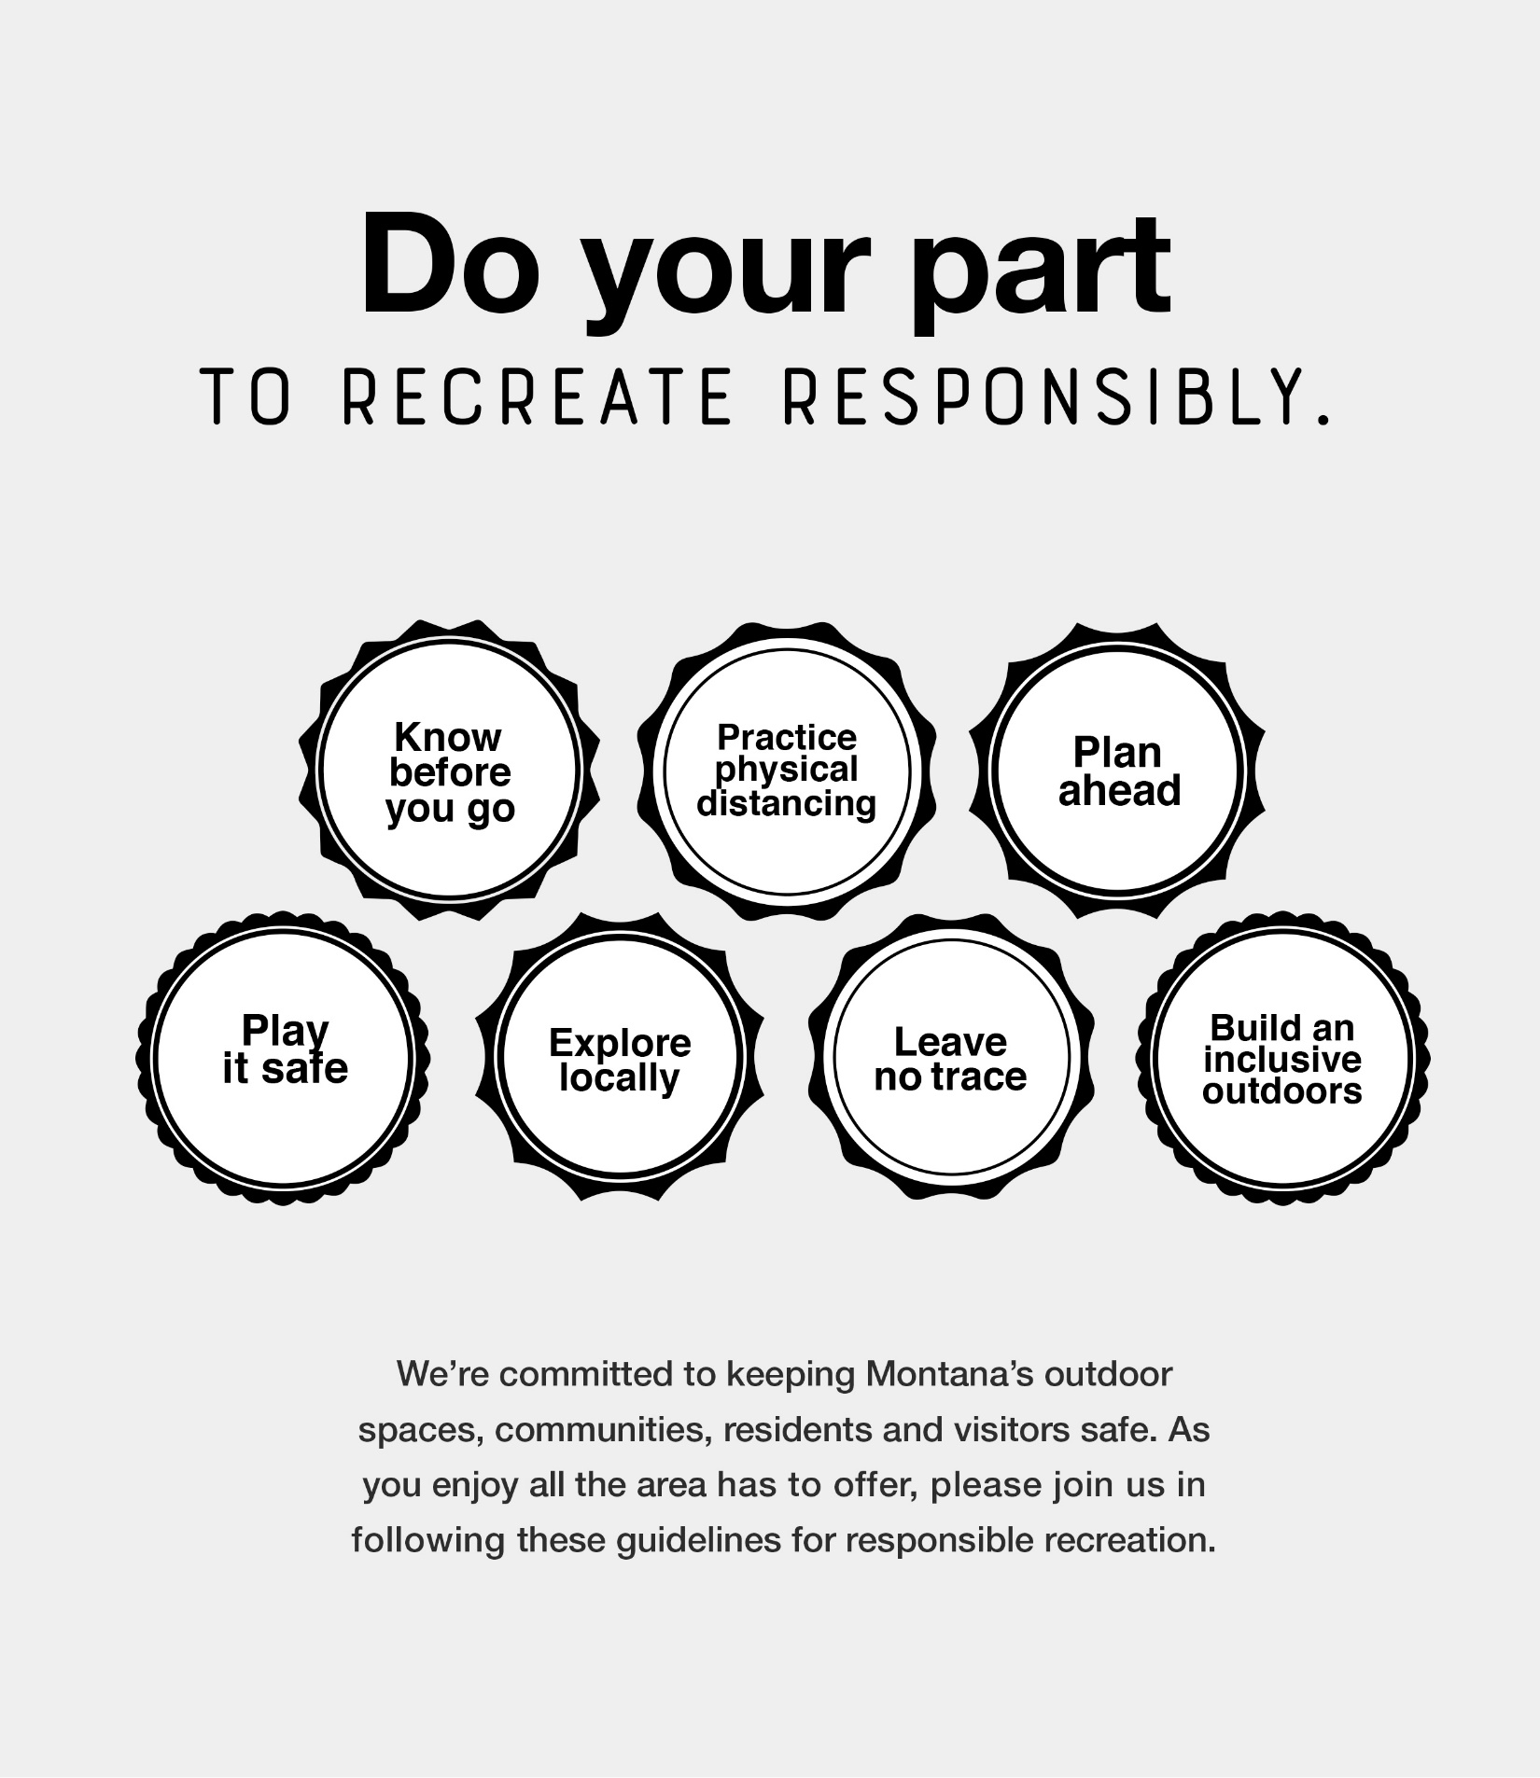

**INSERT PARTNER LOGO HERE**

**RECREATERESPONSIBLY.ORG**

**OR PARTNER URL**