To update images you will need to access the online business resource tool at http://business.visitmt.com. For step by step instructions on how to access business resource tool, please refer to the Tutorial “Update Your Listing”

Towards the bottom of the Information Collection page there is a tool to edit/upload listing images, click on Open Image Tool: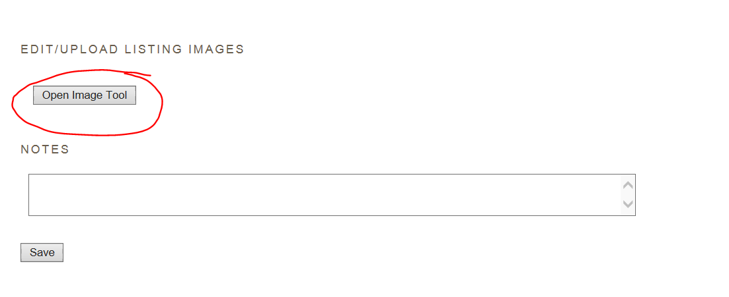
The upload image file will allow you to browse to where your images are stored on your computer and upload them to your listing. Remember the images need to be horizontal and at least 1700 pixels by 1100 pixels.
Once you have browsed to your image hit the upload selected images:
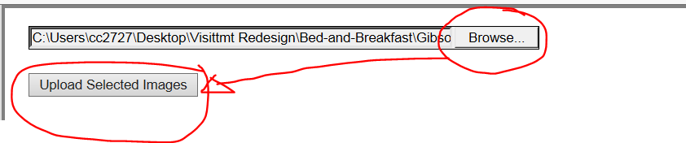
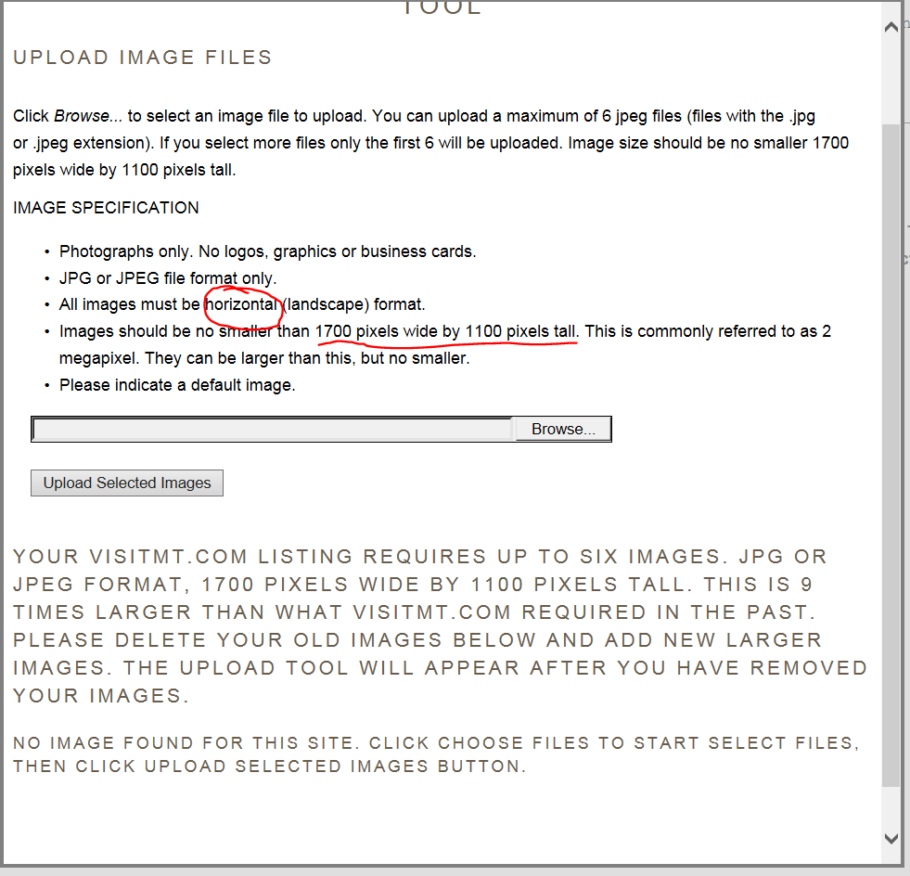

If you do not see a thumbnail image of an image that you have attempted to upload but instead see red text message reminding you that the size must be at least 1700 pixels by 1100 pixels that means your image did not upload and you will have to find a larger image.
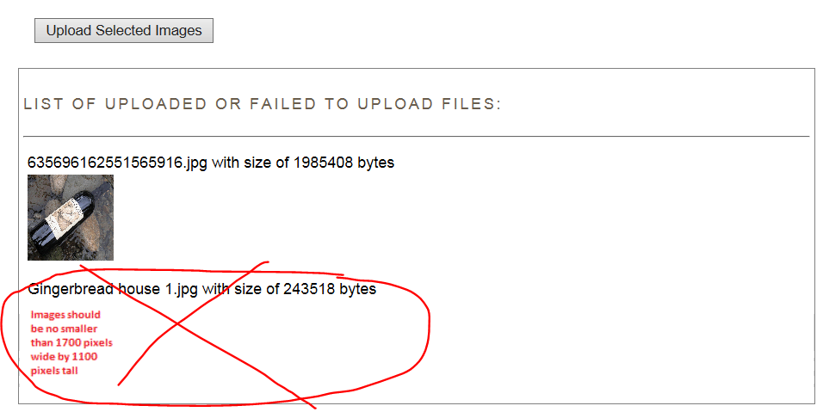

When you are done uploading images, click on the Finish button at the bottom of the image tool:
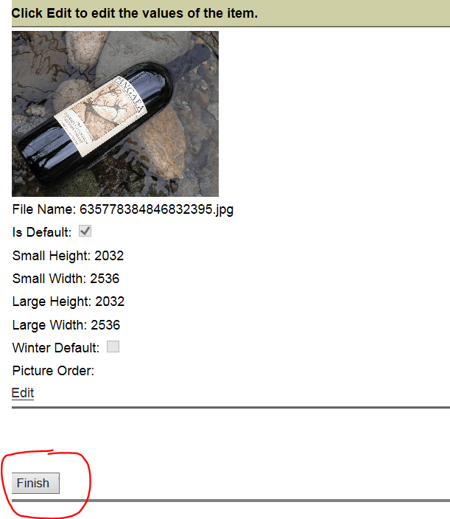
And you need to click on the Save button on the main page to save all the changes in the image tool as well as any other changes you have made.

The first picture added will automatically be your default image. But if you would like to change the default or remove an existing image go back to the image tool
And click on word “Edit” below the thumb image:
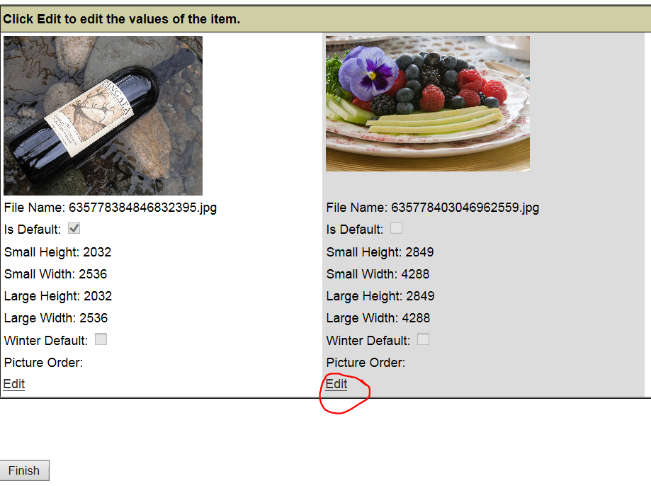

The image will turn yellow and you can either make the image the default by clicking on the words default or delete by clicking on the words delete
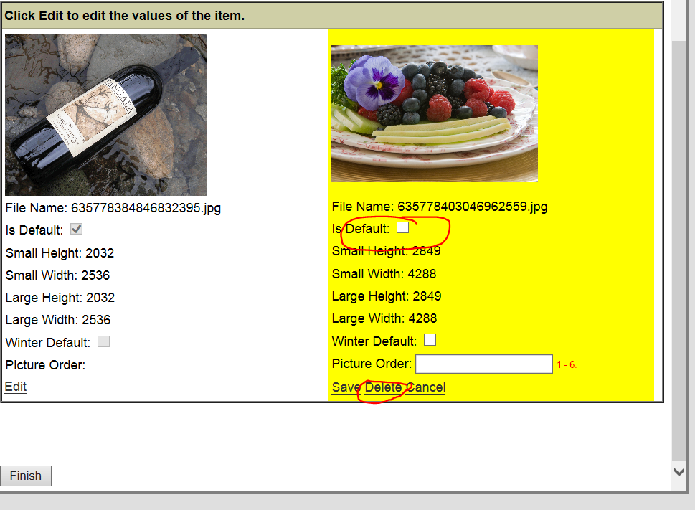

In this case, I want to make the image the default, I select Is Default and hit the save button:
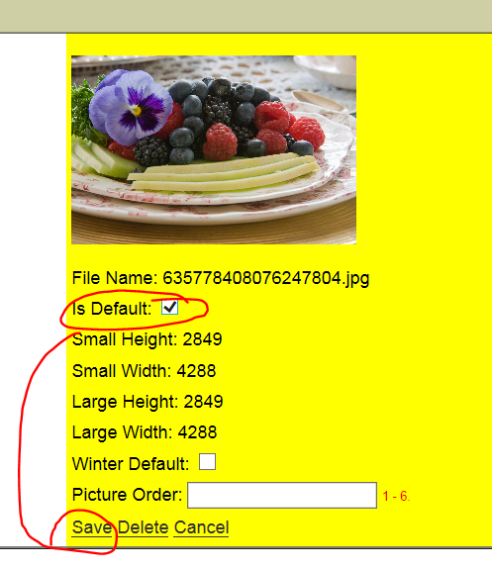
I still will have to hit the finish button in the image tool.

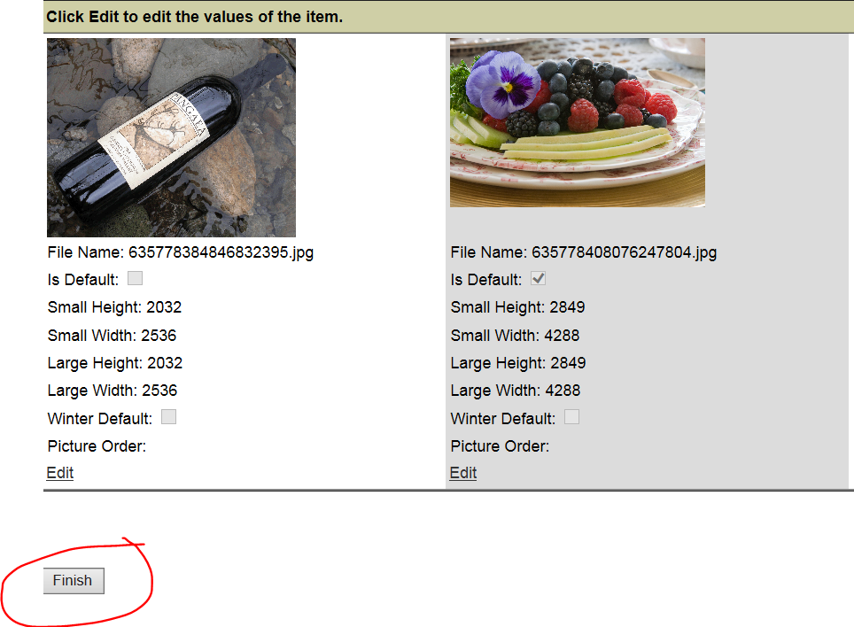
And then the save button at the bottom of the main page:

