Create a New Listing
Using the online business resource tool at http://business.visitmt.com you will create a login to the Montana e-pass system, or log into the Montana e-pass system:
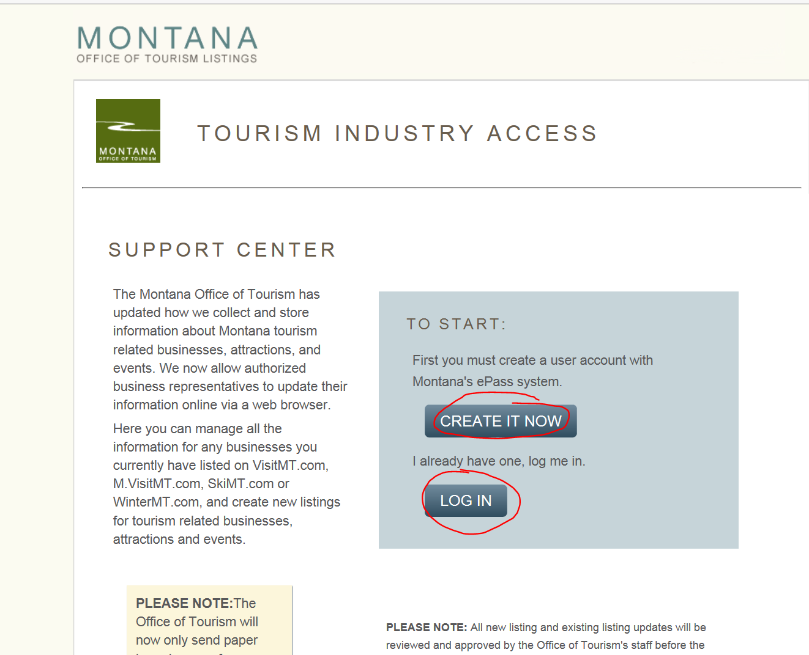

Clicking either link will take you to the Montana e-pass page where you will select the Login with ePass Montana selection:
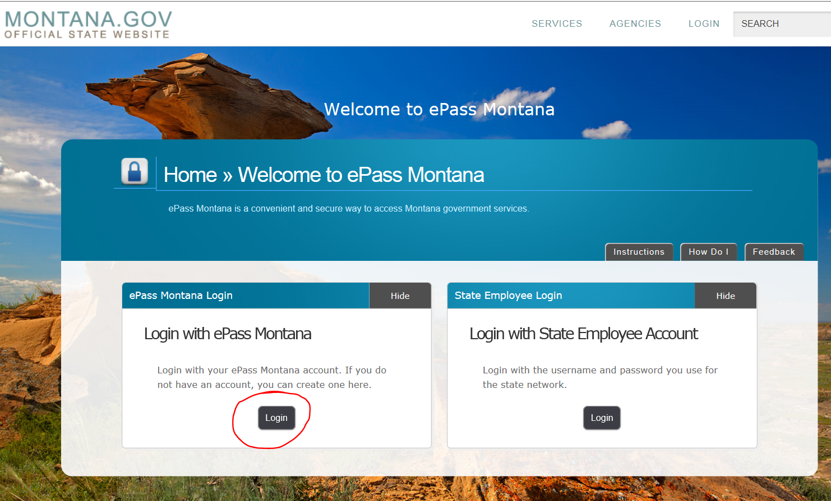

If you have used the Montana e-pass system before you will login with your existing username and password:
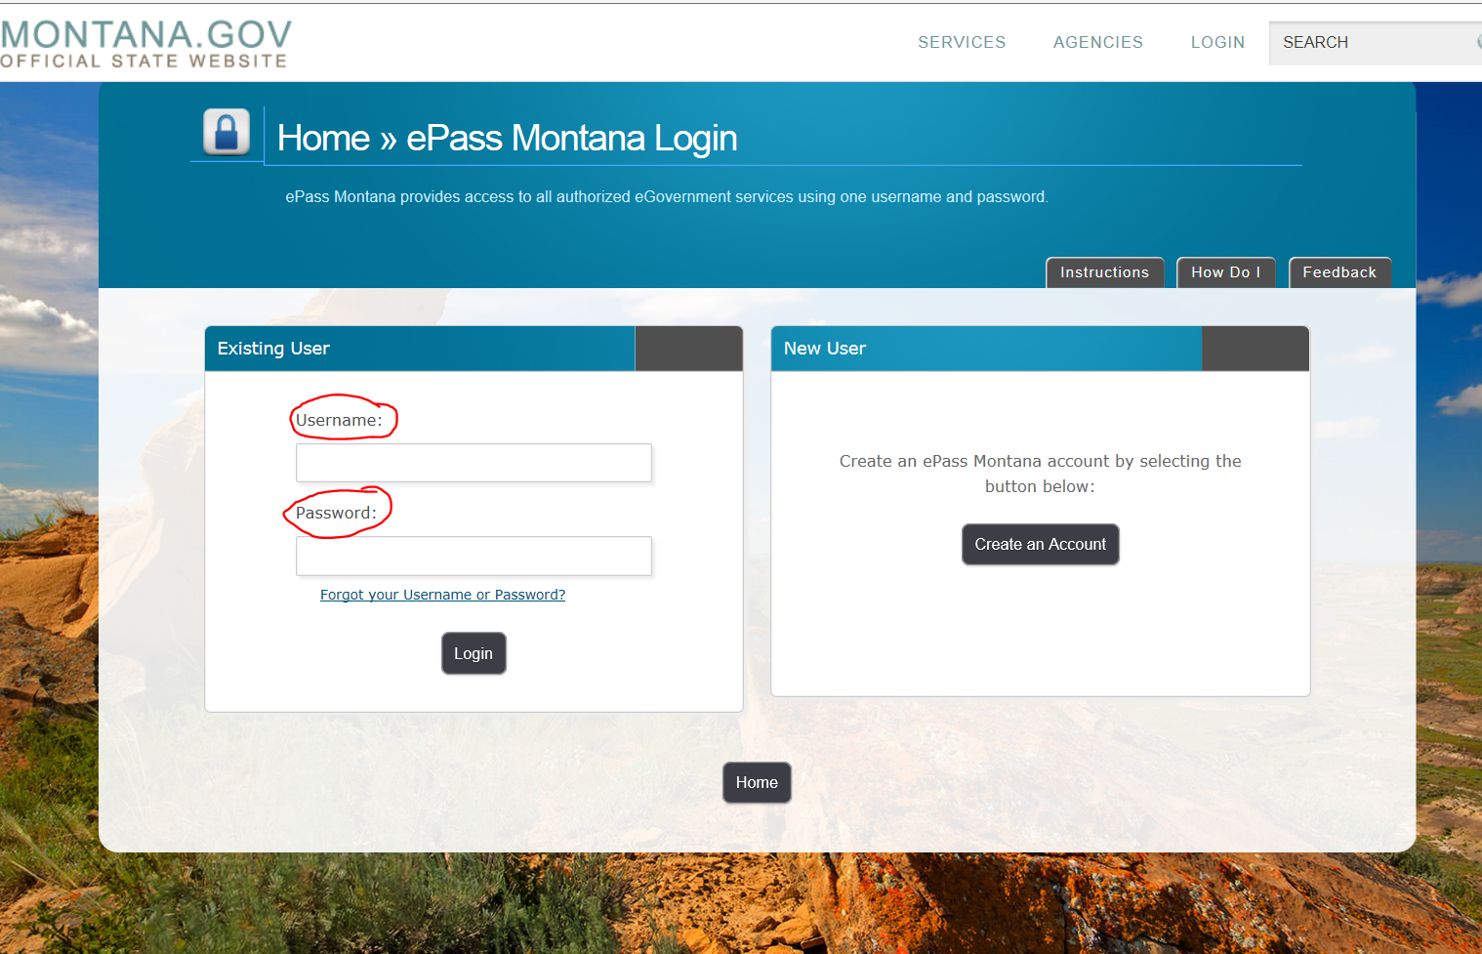

If you do not have a Montana e-pass you will create one:

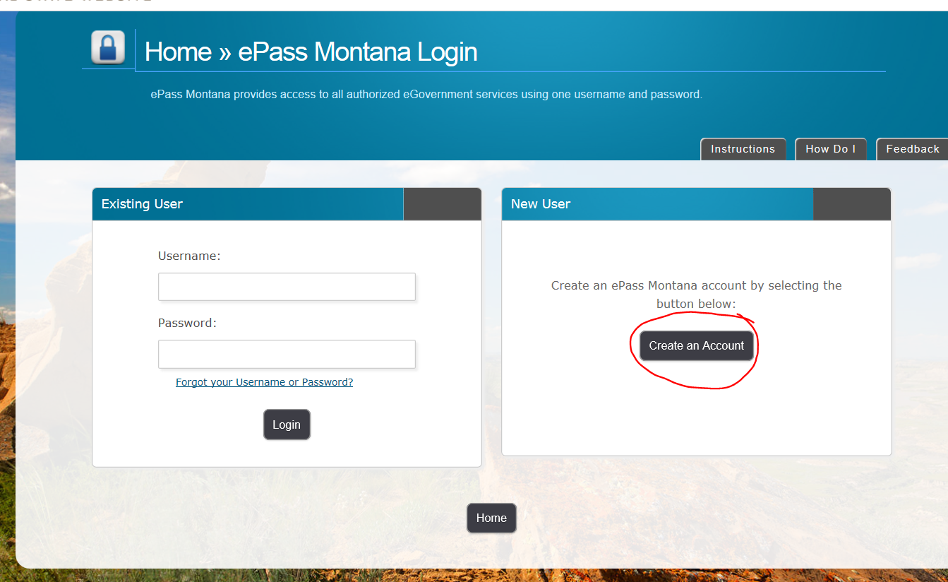

On the create a Montana e-pass you will fill in every box that is asterisked and when completed; click on save changes. Remember that your username must be at least 6 characters long, password must be at least 8 characters long, password must use both letters and numbers, password must be different than your username, password is case sensitive. Save your created username and password for future use.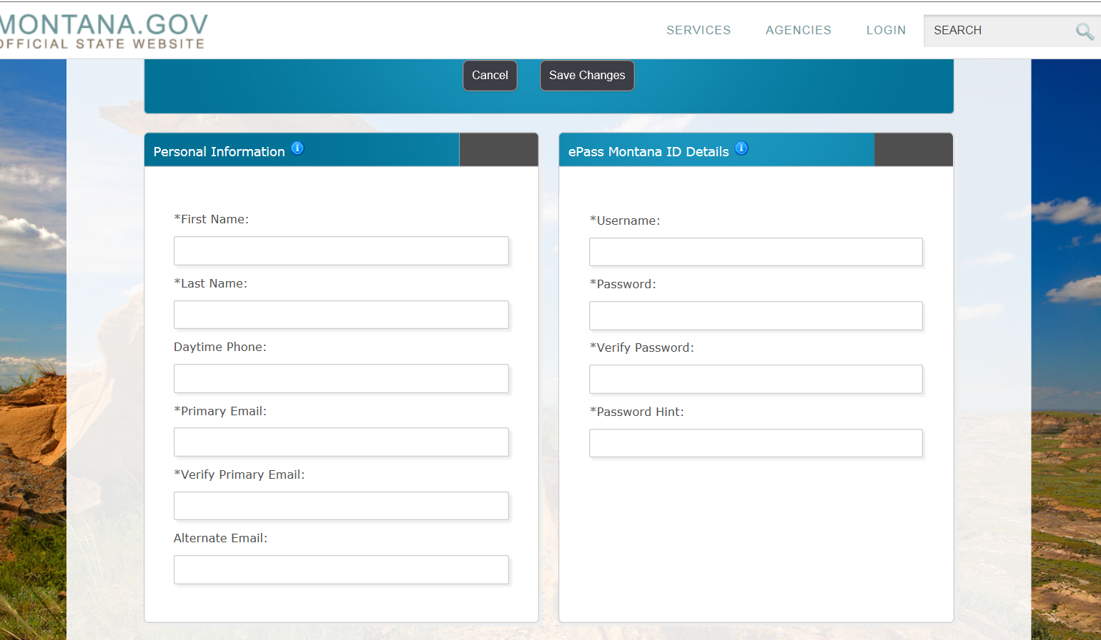

It is not necessary to fill out the Registered User Information box (it is for those who are already registered) and at the bottom of the page click on the button that says “Save Changes”
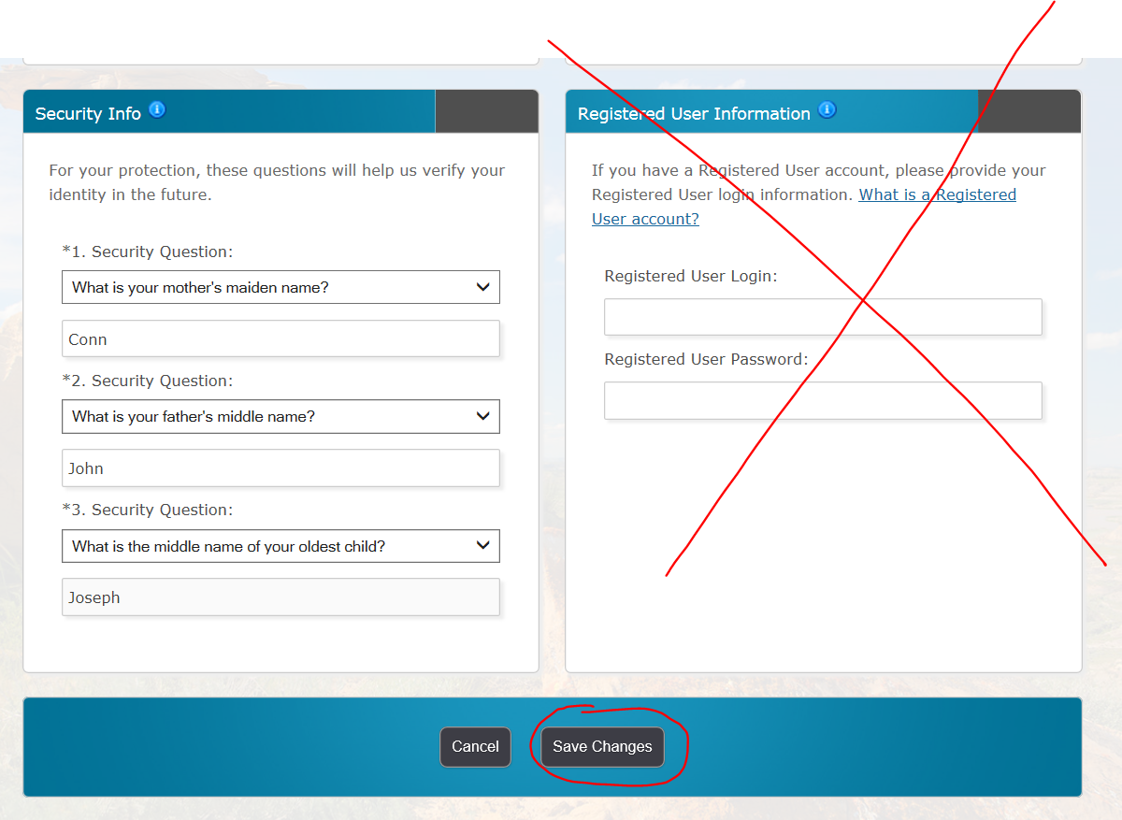

Once you have done that you should be directed back to the online business resource tool. Where you will select Create a New Listing:
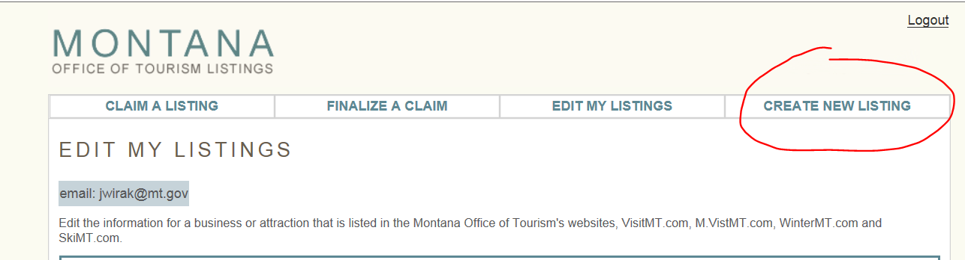

This will take you to a Terms & Conditions page, where you must check “Accept” in order to move to the next page.
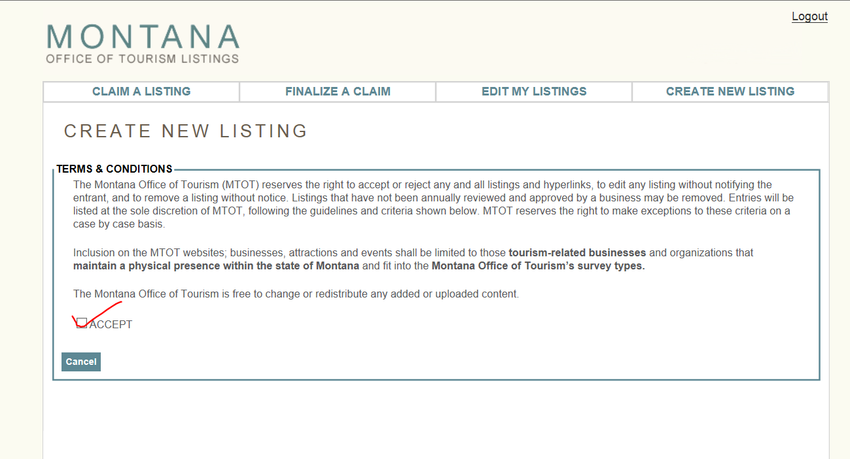
The next page is screening for existing listings in the database. Fill in all the boxes that are asterisked
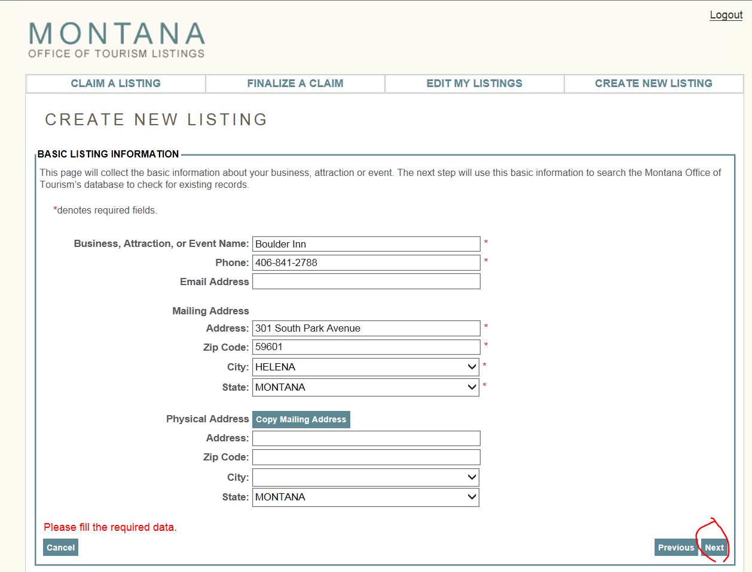
If that section does not find an existing listing, it will direct you to the next page where you will select the category that best describes the type of listing you want to create:
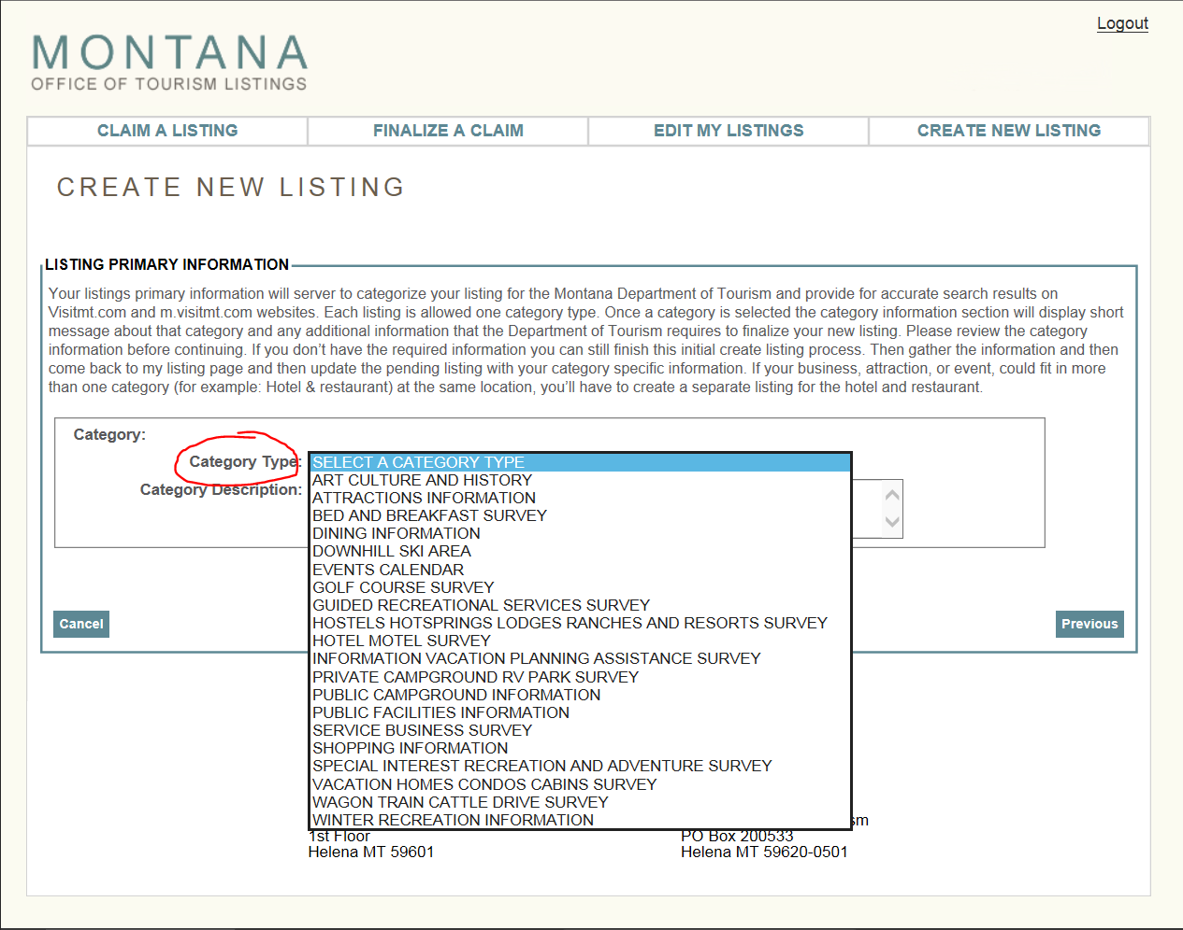
The next page will give me additional information that I will need to provide in order to create a new listing.
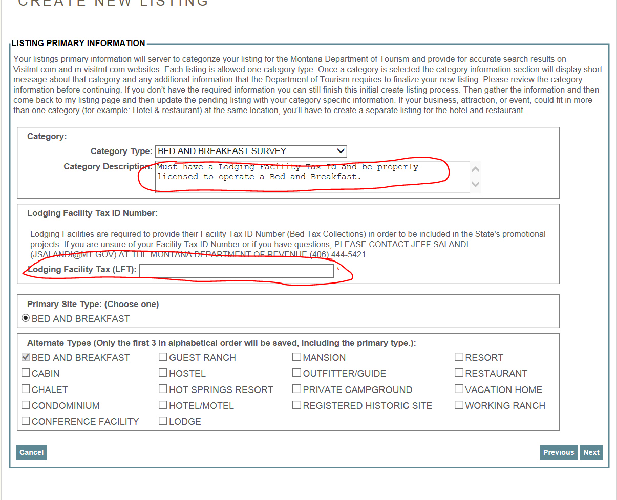
Once I have provided the required information, I will begin filling out the information needed to create a listing. Please fill out all of the information.
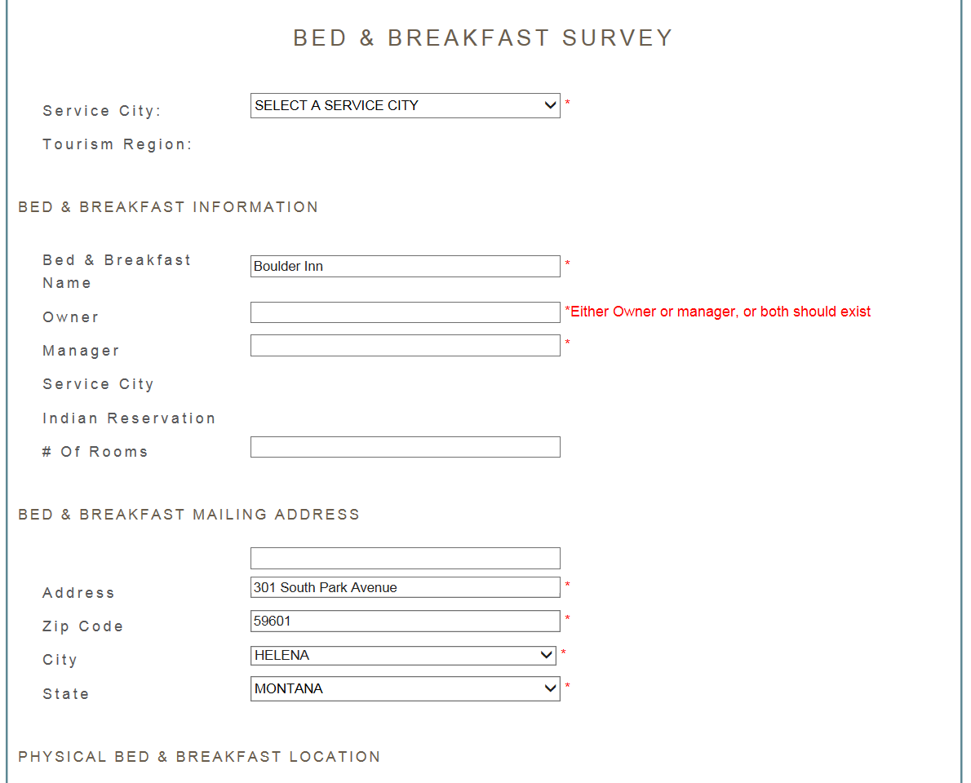
To create a map pin locator. Put in your physical location (street address) and hit the update Lat/Long button
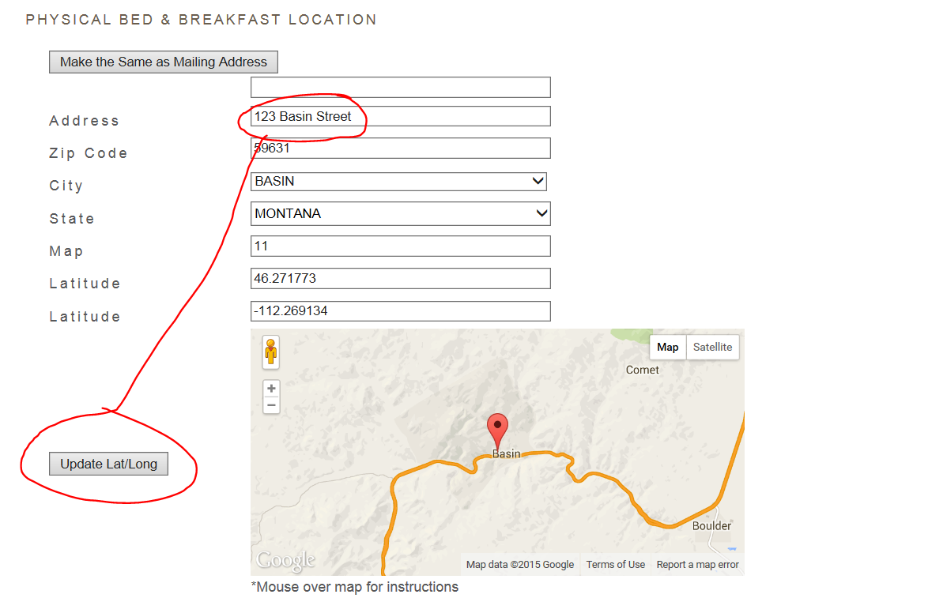

If the address did not generate the correct location, click on the map indicator and drag it to the correct location and drop the locator and do not use the update Lat/Long button. Dragging the locator automatically is changing the latitude and longitude.
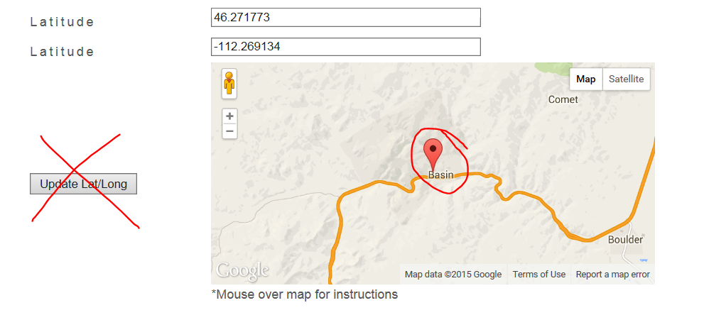

Towards the bottom of the page there is a tool to edit/upload listing images, click on Open Image Tool:

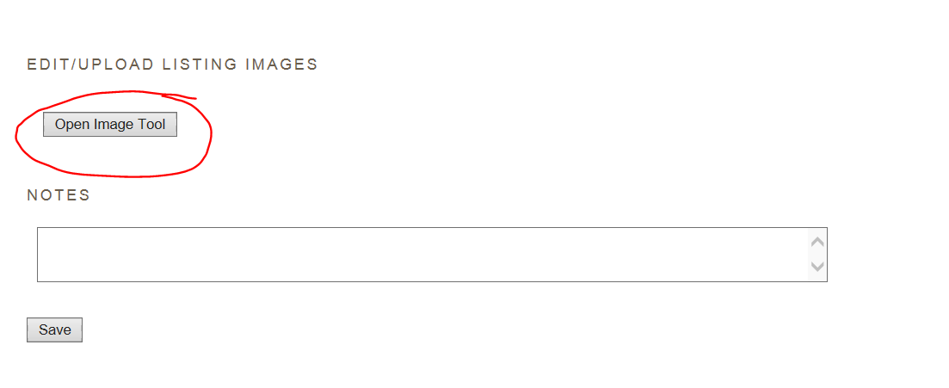
The upload image file will allow you to browse to where your images are stored on your computer and upload them to your listing. Remember the images need to be horizontal and at least 1700 pixels by 1100 pixels.
Once you have browsed to your image hit the upload selected images:
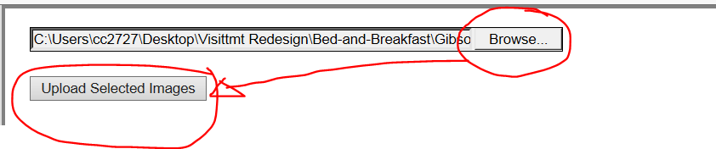
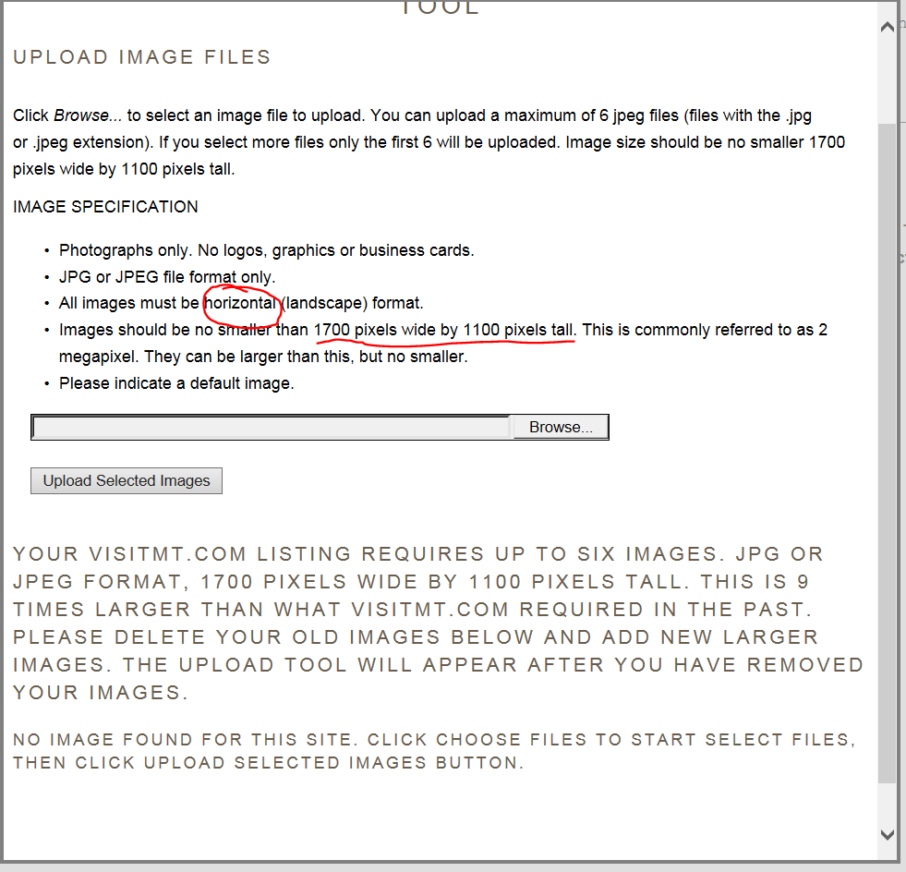

If you do not see a thumbnail image of an image that you have attempted to upload but instead see red text message reminding you that the size must be at least 1700 pixels by 1100 pixels that means your image did not upload and you will have to find a larger image.
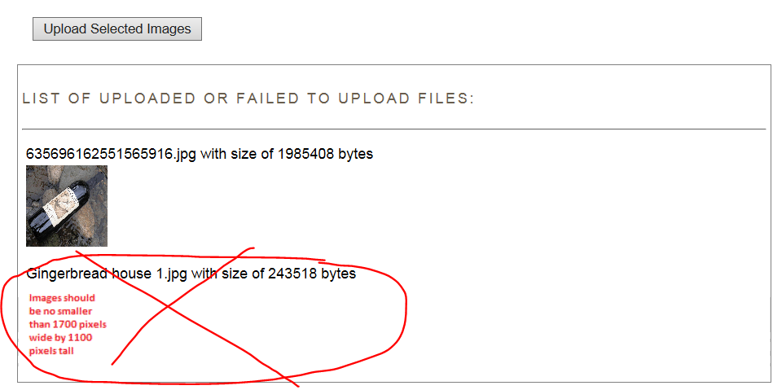

When you are done uploading images, click on the Finish button at the bottom of the image tool:
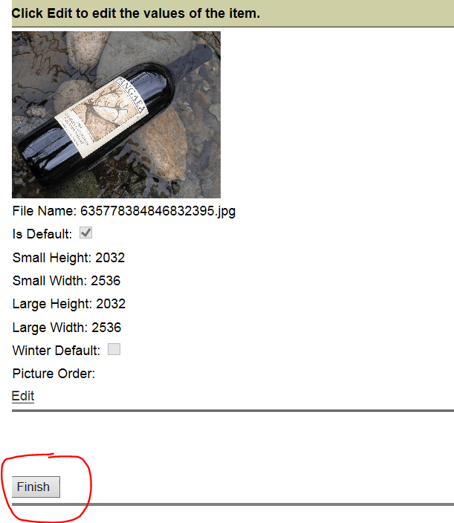
And you need to click on the Save button on the main page to save all the changes in the image tool as well as any other changes you have made.

The first picture added will automatically be your default image. But if you would like to change the default or remove an existing image go back to the image tool
And click on word “Edit” below the thumb image:
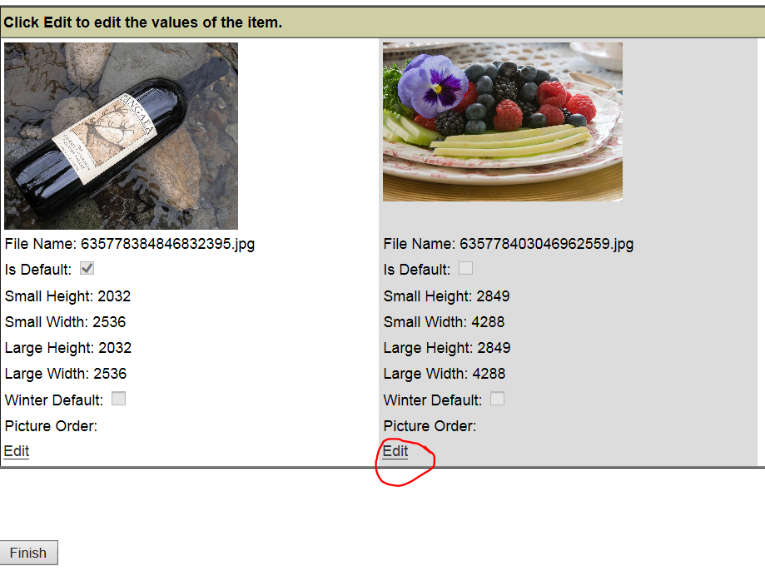

The image will turn yellow and you can either make the image the default by clicking on the words default or delete by clicking on the words delete
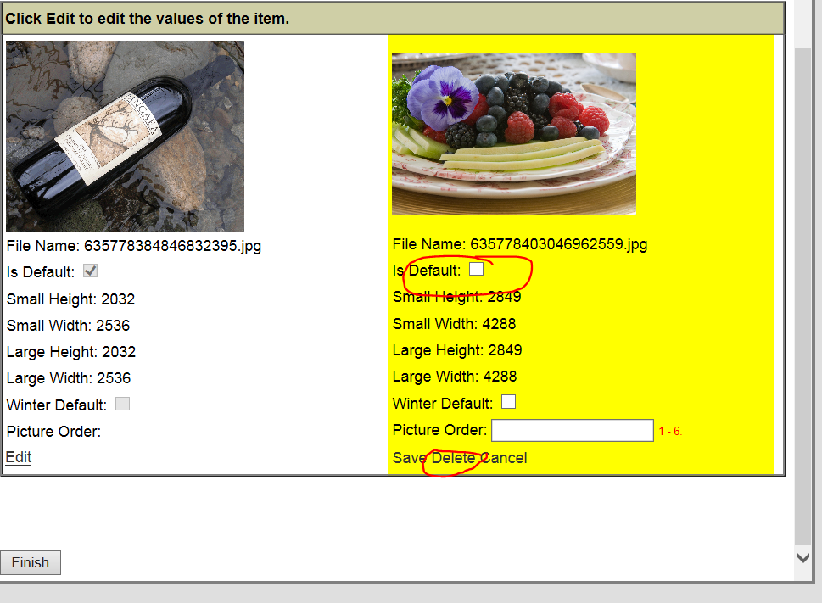

In this case, I want to make the image the default, I select Is Default and hit the save button:
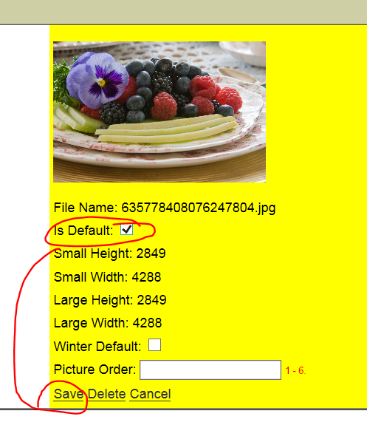
I still will have to hit the finish button in the image tool.

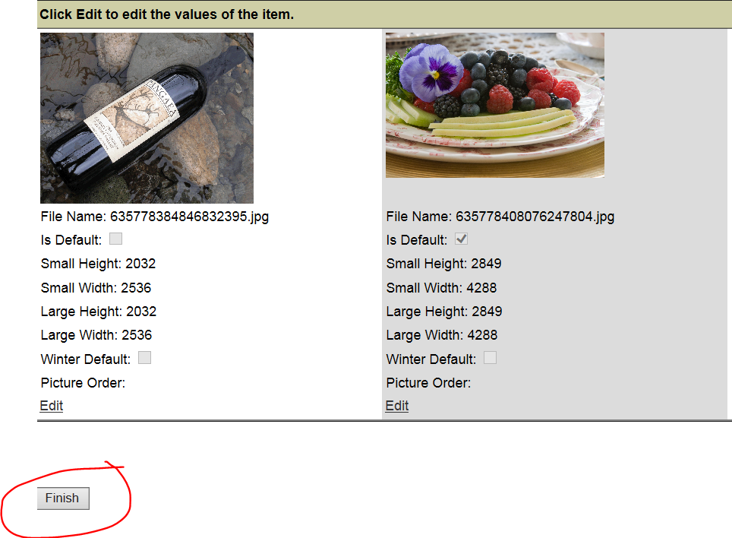
And then the save button at the bottom of the main page:

Once you have filled out all your information, you will get confirmation of this
