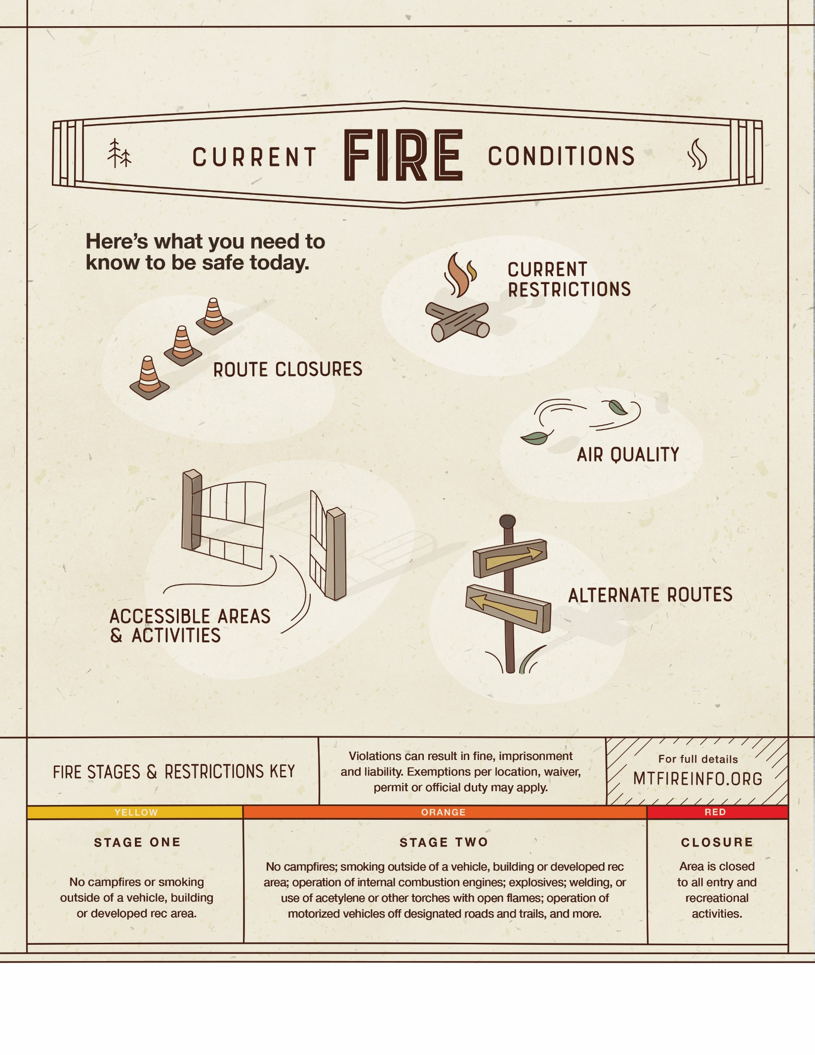

Find the latest fire details at [URL].

[ INSERT AREAS AND ACTIVITIES HERE ]

[ INSERT ROUTES HERE ]

[ INSERT AIR QUALITY DETAILS HERE ]

[ INSERT CURRENT FIRE STAGE

1,2 OR CLOSURE HERE ]

[ INSERT LOCATIONS HERE ]

**UPDATED: TODAY’S DATE AT TIME**

**City, Montana**

**INSERT PARTNER LOGO HERE**