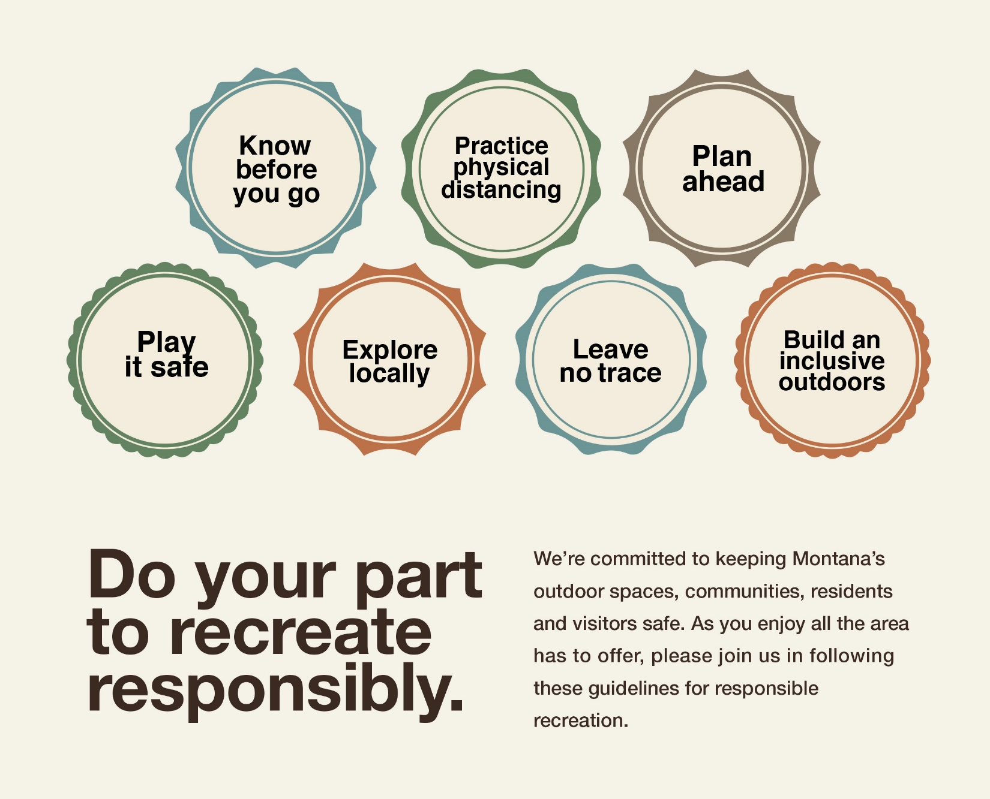

USE THIS IMAGE OR REPLACE WITH YOUR OWN

**INSERT PARTNER LOGO HERE**

**RECREATERESPONSIBLY.ORG**

**OR PARTNER URL**