RECREATE RESPONSIBLY SOCIAL COPY

Use this document as a guide to help pair copy with the provided social post artwork (sized for Facebook, Instagram and Twitter). Standalone badge artwork has also been provided if you prefer to customize the background images of your social posts.

RECREATE RESPONSIBLY OVERVIEW POST:
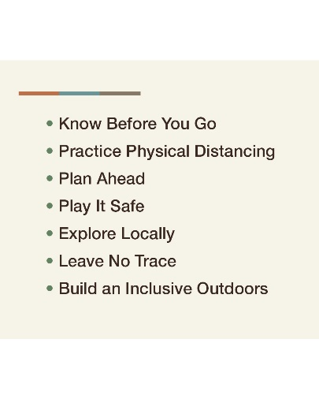

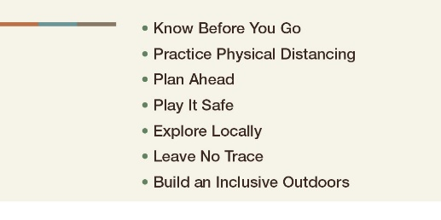
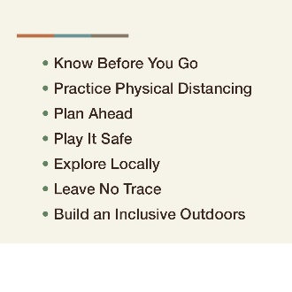

[Twitter/Facebook]

We’re committed to keeping Montana’s outdoor spaces, communities, residents and visitors safe. As you enjoy all the area has to offer, please join us in following these guidelines for responsible recreation. To learn more, visit [insert your URL]. #RecreateResponsibly

[Instagram]

We’re committed to keeping Montana’s outdoor spaces, communities, residents and visitors safe. As you enjoy all the area has to offer, please join us in following these guidelines for responsible recreation. Click the link in our bio to learn more. #RecreateResponsibly
For URLs, you can also direct people to visitmt.com/montana-matters or recreateresponsibly.org

ACTION-SPECIFIC POSTS:

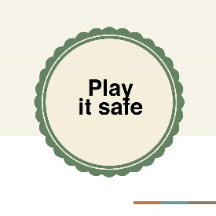
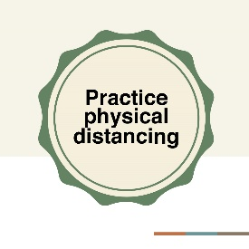

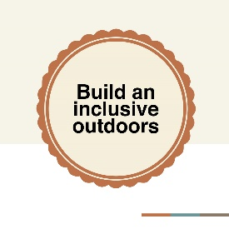
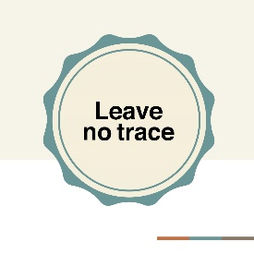

Know Before You Go

[ALL]

One way to #RecreateResponsibly is to check the status of the place you’d like to visit before arriving. It’s good to have a backup plan if your destination is closed or crowded.
Option to customize: Add your hours, capacity limit, how to make reservations or anything else that would be helpful for people to know before arriving at your destination.

Consider adding where people can find updates on your specific, how to make reservations,

Practice Physical Distancing

[ALL]

On the trail, make sure to give others space and be prepared to cover your nose or mouth. Keep your groups small and stay home if you’re sick. #RecreateResponsibly
Option to customize: Add details or specific guidelines about the space at your destination. If your destination doesn’t include trails, swap it out for what you do offer (river, campgrounds, picnic areas, etc.).

Consider adding where people can find updates on your specific, how to make reservations,

Plan Ahead

[ALL]

Before you #RecreateResponsibly, check our local regulations for the latest safety measures. Facilities might be closed, so consider packing a lunch and bring essentials like hand sanitizer and a face covering.
Option to customize: Mention if your destination has any closures or limited hours.

Play It Safe

[ALL]

As you #RecreateResponsibly, have fun but know your limits. Take it slow and choose lower-risk activities to help our strained search and rescue operations and health care resources.
Option to customize: Consider adding safety tips specific to your area or activities, or where people can go to learn more about safe recreation.

Explore Locally

[ALL]

Our home is full of local parks, trails and public spaces. Explore locally while being mindful of your impact on the surrounding communities. #RecreateResponsibly
Option to customize: Swap “our home” with you specific area or destination. Share ideas for local places to go, or where people can find a list of area attractions.

Leave No Trace

[ALL]

How can you #RecreateResponsibly? Leave no trace by cleaning up properly and taking your trash with you. It’s important to respect public lands and waters, as well as Native and local communities.
Option to customize: Mention access (or lack of access) to trash and recycling at your destination, or how leaving trash can negatively impact your destination (wildlife, pollution, etc.).

Build an Inclusive Outdoors

[ALL]

Join us in building an inclusive outdoors! Do your part to help make our outdoor spaces safe and welcoming for all identities and abilities. #RecreateResponsibly
Option to customize: Mention ways your destination or area is accommodating and inclusive (accessible trails/restrooms, handicap parking, resources for the hearing and visually impaired, etc.)

EXAMPLES OF CUSTOMIZATION WITH STANDALONE BADGE ARTWORK:
