Claim Your Listing
The online business resource tool is located at http://business.visitmt.com To access the tool, you will have to either create a login or login to the Montana e-pass system. Select either button:
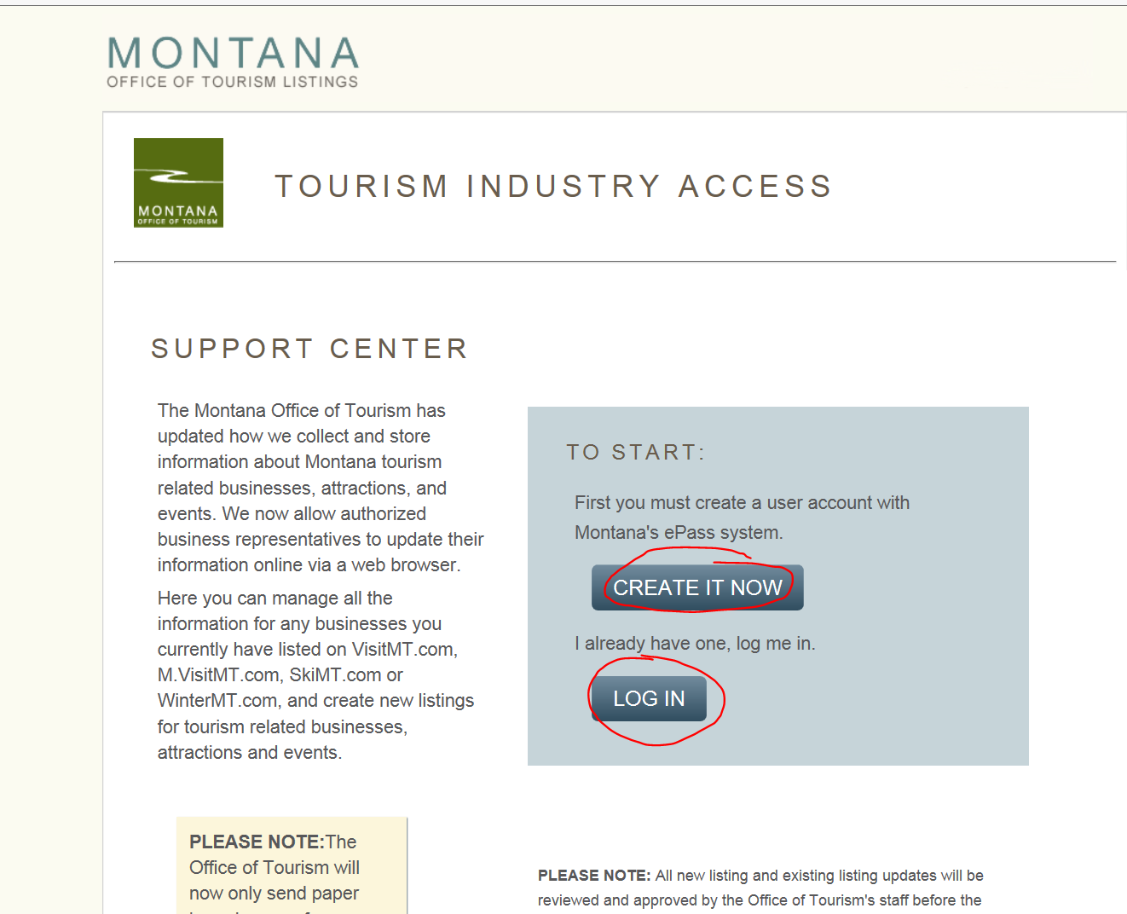
Clicking either link will take you to the Montana e-pass page where you will select the Login with ePass Montana selection: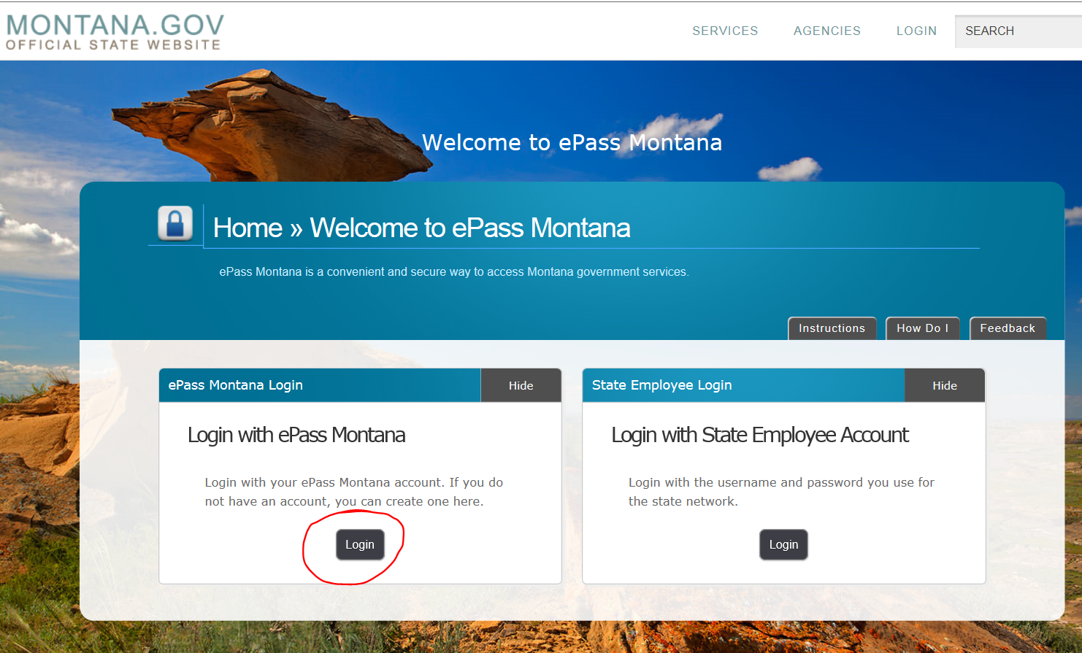

If you have used the Montana e-pass system before you will login with your existing username and password:
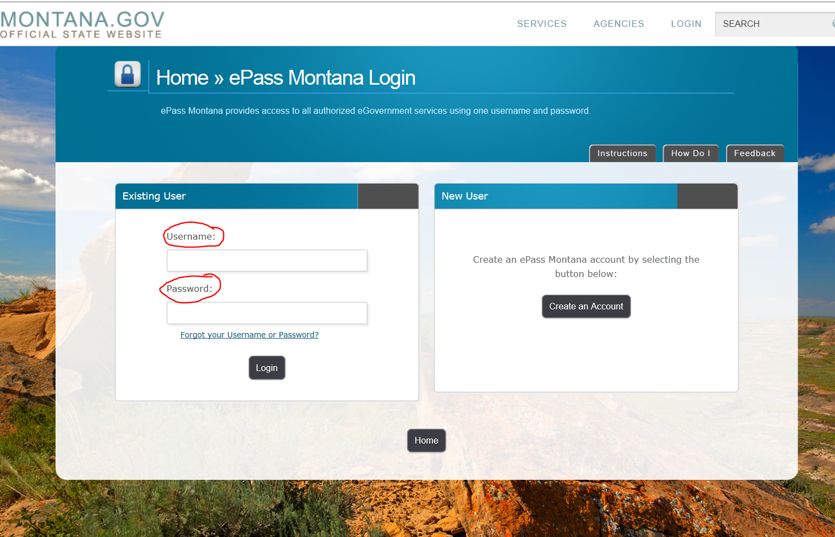

If you do not have a Montana e-pass you will create one: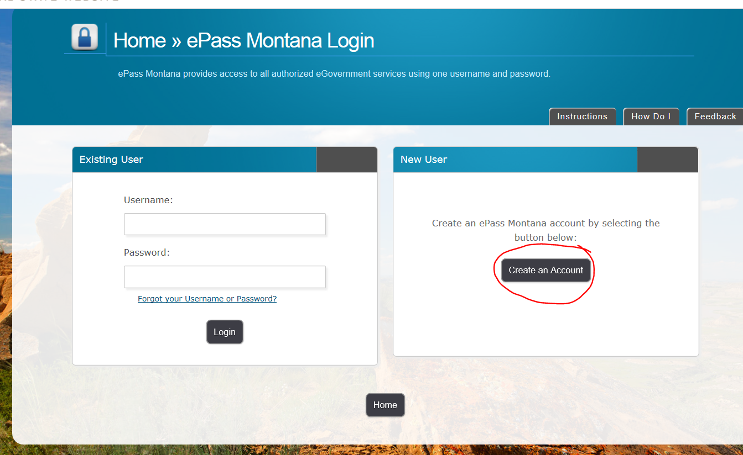

On the create a Montana e-pass you will fill in every box that is asterisked and when completed; click on save changes. Remember that your username must be at least 6 characters long, password must be at least 8 characters long, password must use both letters and numbers, password must be different than your username, password is case sensitive. Save your created username and password for future use.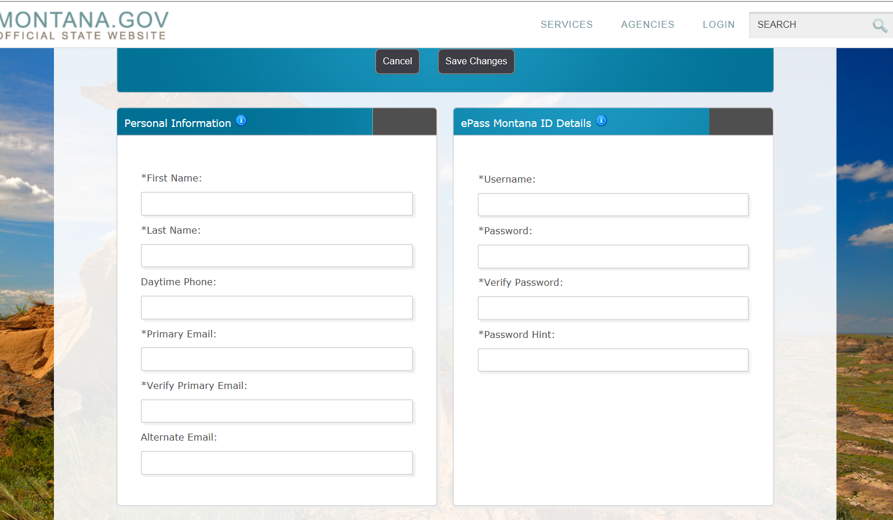

It is not necessary to fill out the Registered User Information box (it is for those who are already registered) and at the bottom of the page click on the button that says “Save Changes”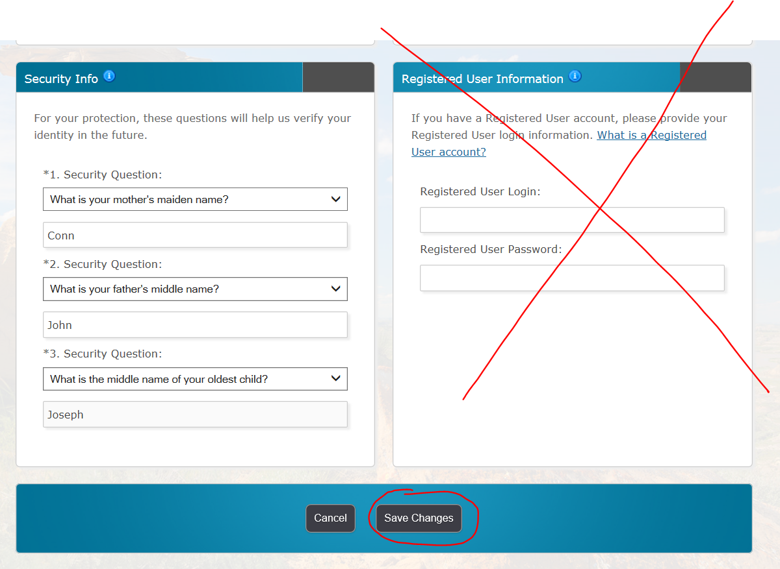

Your successful completion will have a Welcome salutation
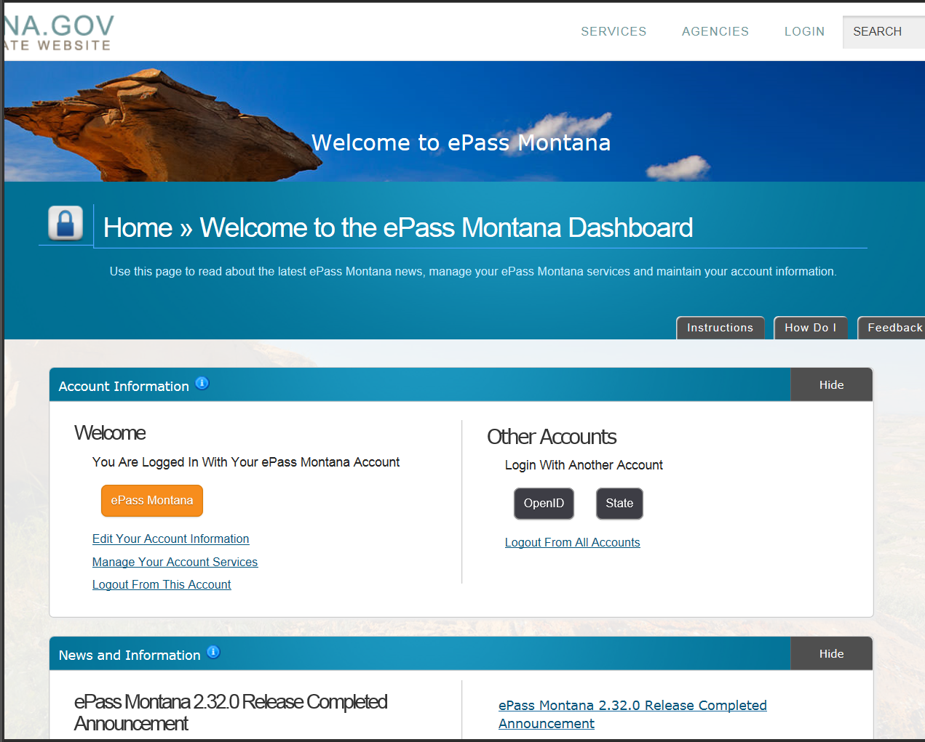

To get to the online business resource tool, scroll down the page to “Add a Service” and click on “Business Resource and Listing Update Tool”
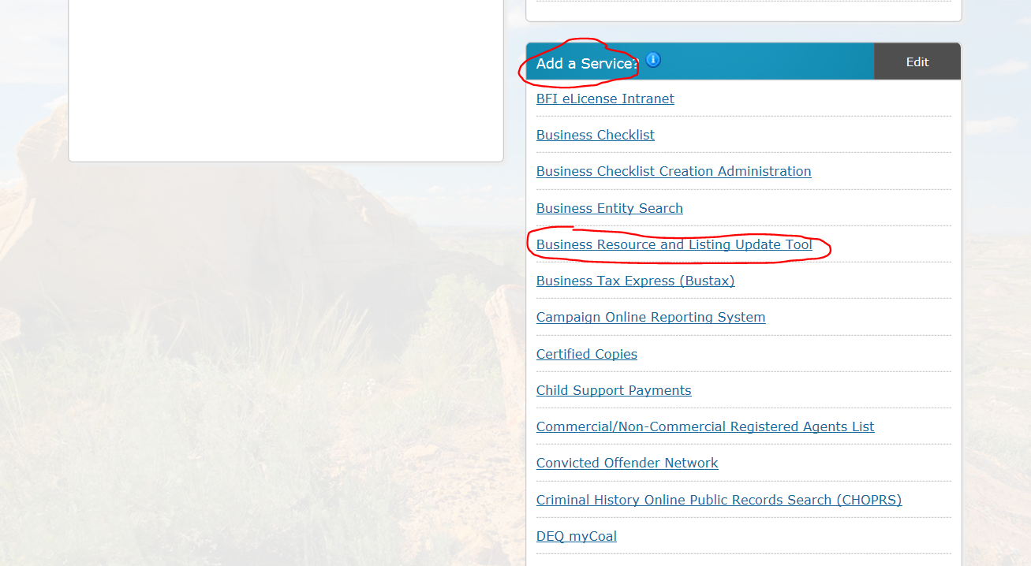
Click on “Log In’ once again
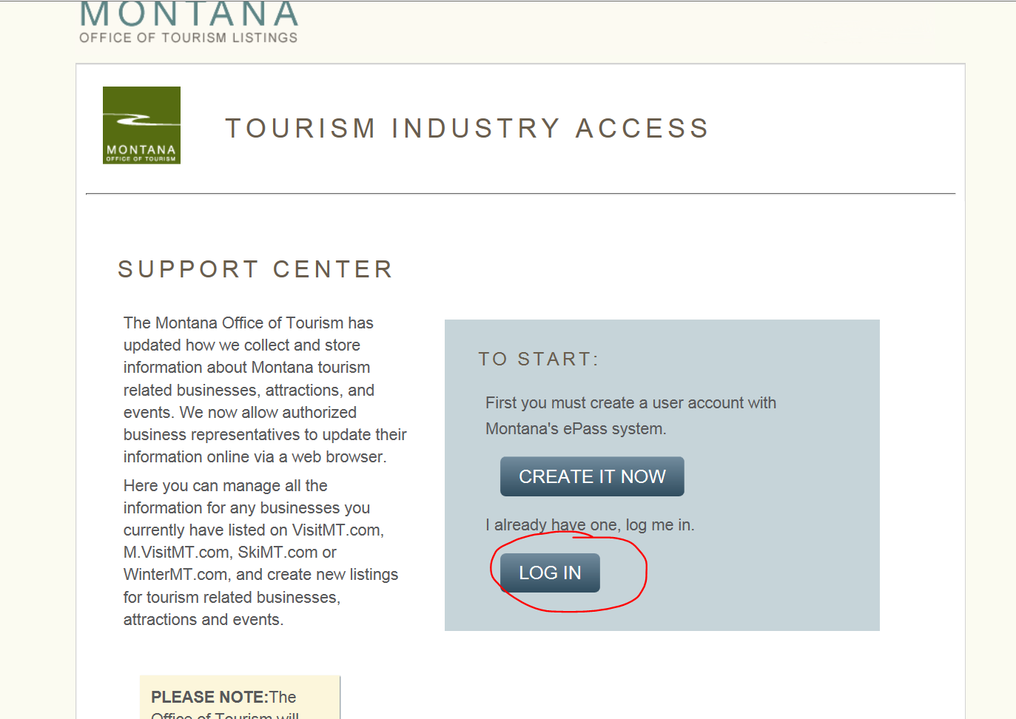

It will take you to this page and select “Claim a Listing”
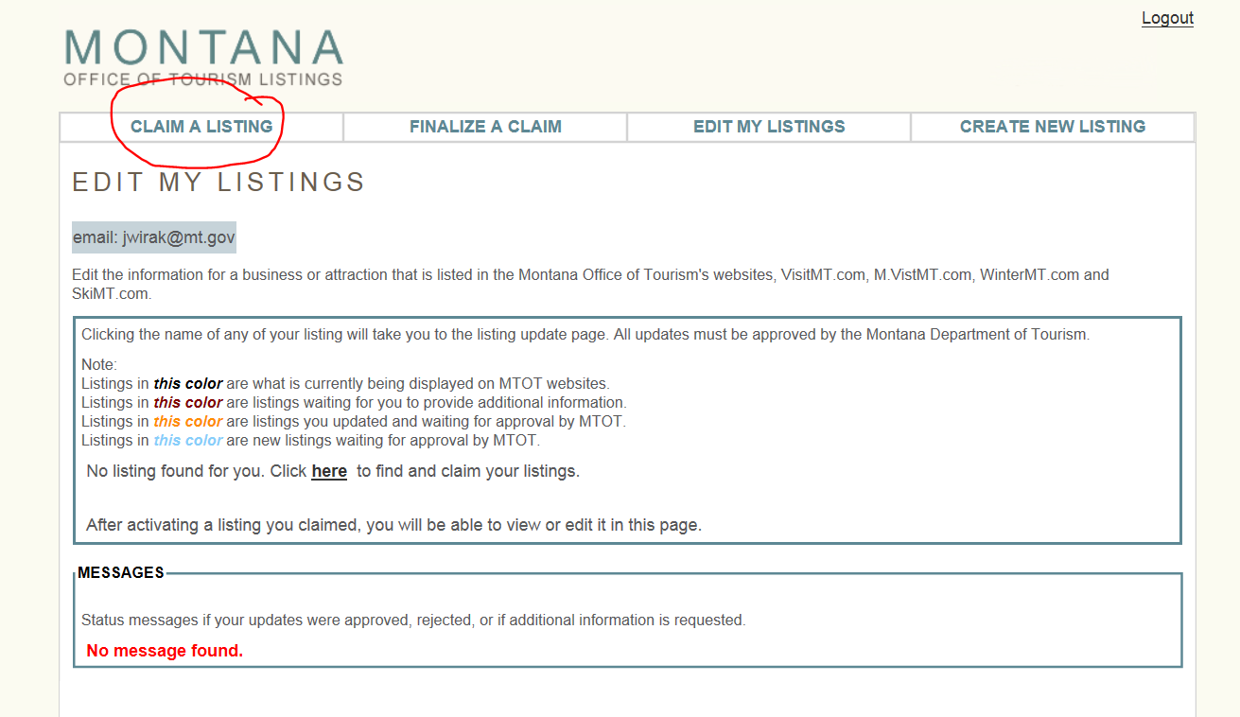
On the search page, the best results are obtained when you use the least number of criteria looking for your listing. The name you enter should be exactly as you are currently displaying on Visitmt.com, or enter your phone number prefaced by 406-***-****
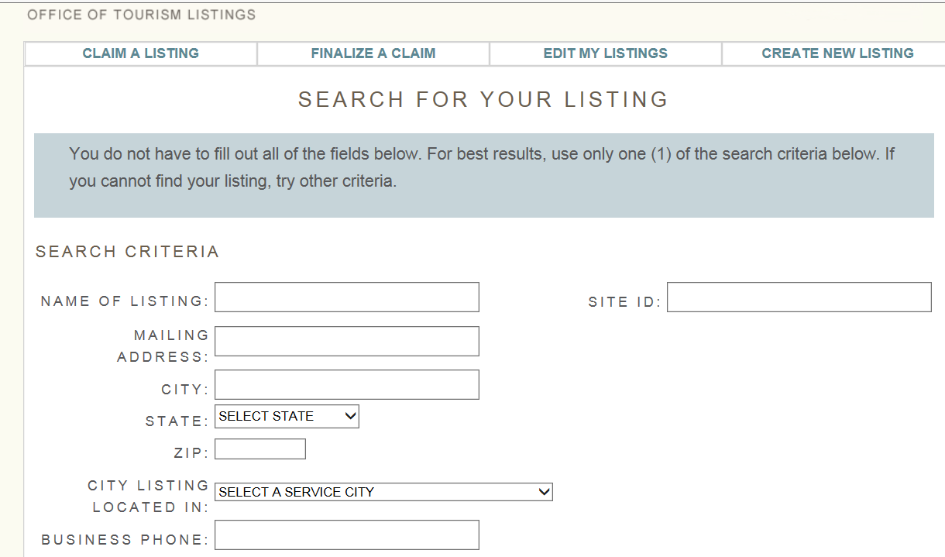

If the search result page has found your listing, click on your name:
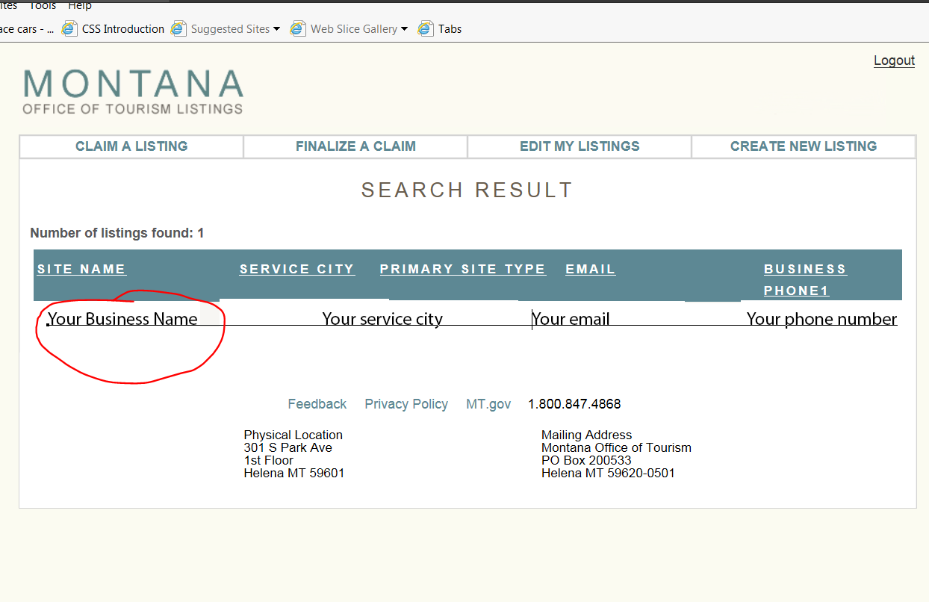
This will take you to a claim listing page where your basic contact information is printed. Click on the claim listing button.
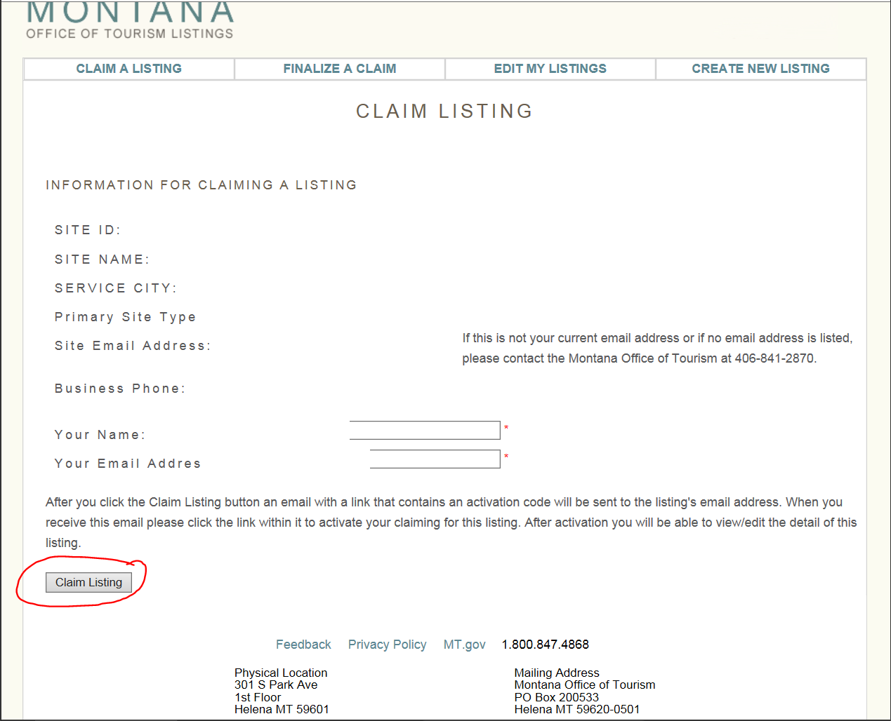

Which will bring you to a notification page that tells you that an email has been sent to your email account with a code that is needed to finalize your claim:
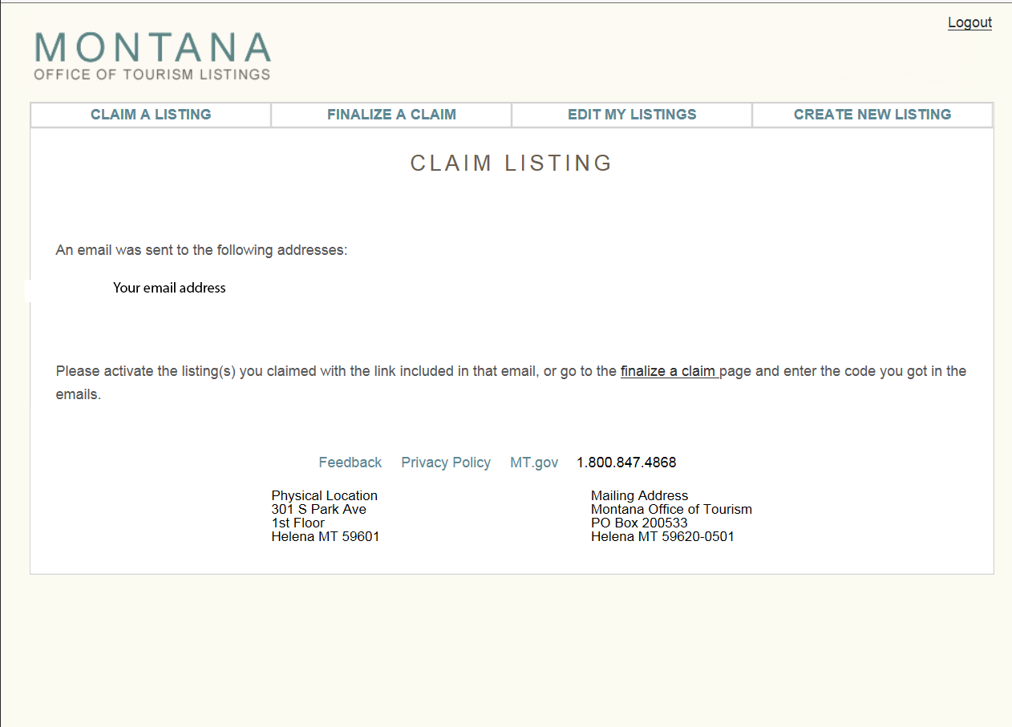
The email will look like this:
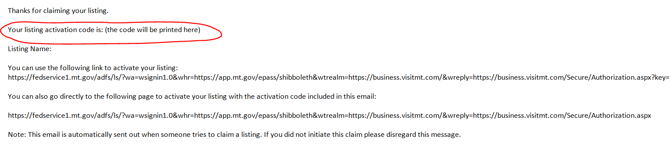

Once you have copied the code from your email account, return to the online business resource tool with your code and select the tal “Finalize a Claim” and paste the code into the box and click on the “Claim Listing” button
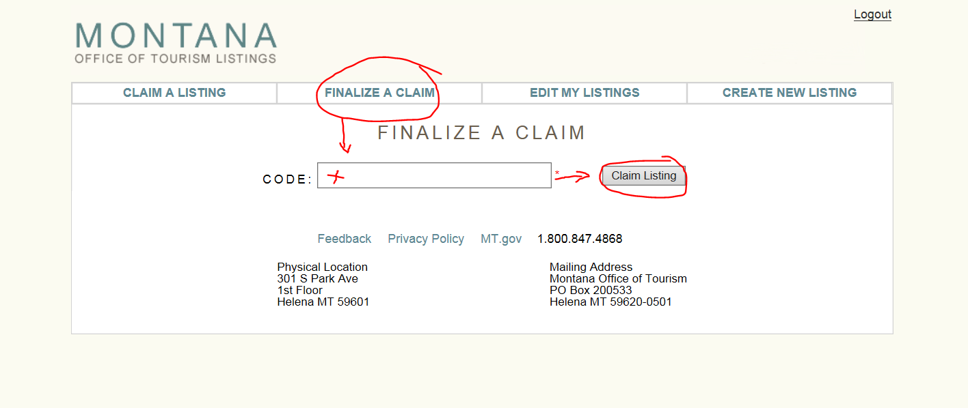
This will automatically take you to the edit my listing tab, where you will click on your name and it will bring you to a page where you will review and update your information:
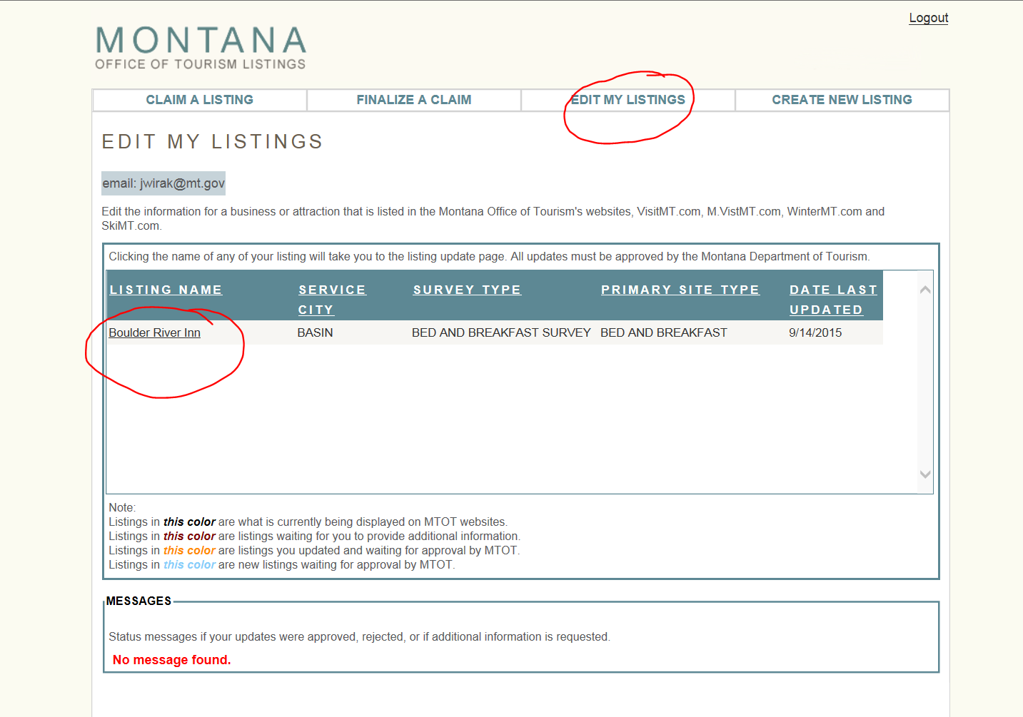

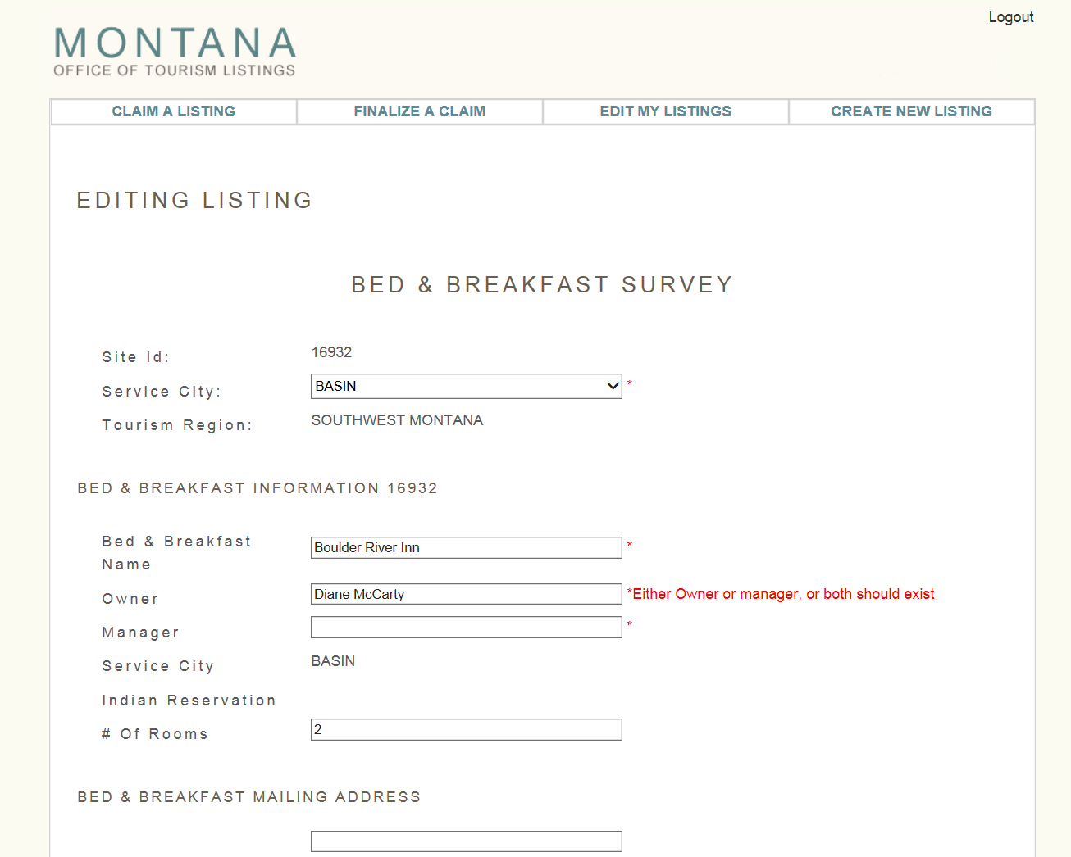

To correct the location of the map indicator. Put in your physical location (street address) and hit the update Lat/Long button
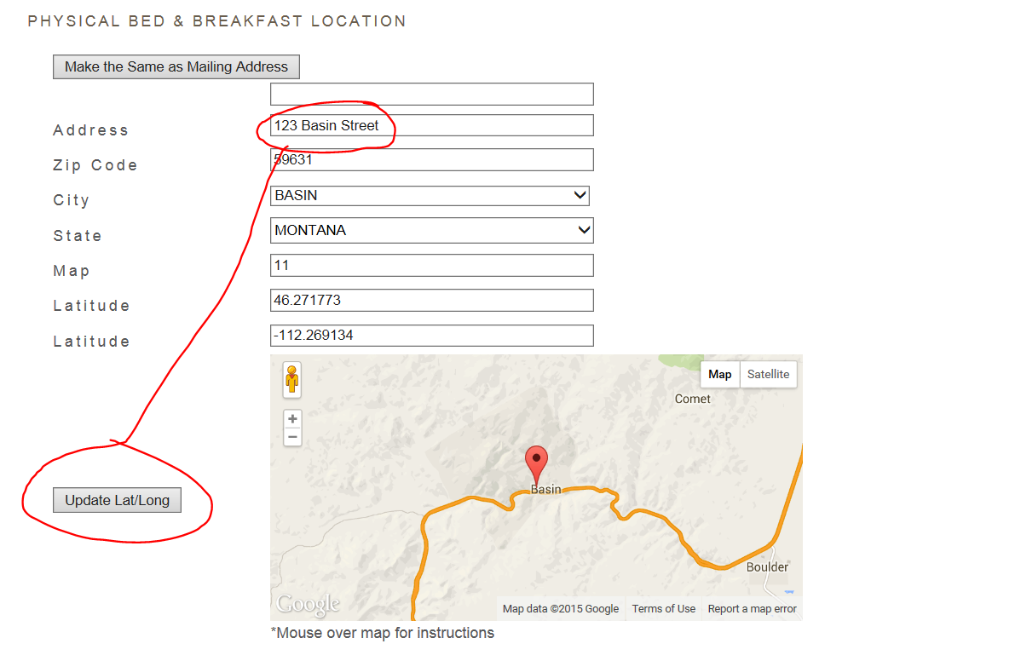

If the address did not generate the correct location, click on the map indicator and drag it to the correct location and drop the locator and do not use the update Lat/Long button. Dragging the locator automatically is changing the latitude and longitude.
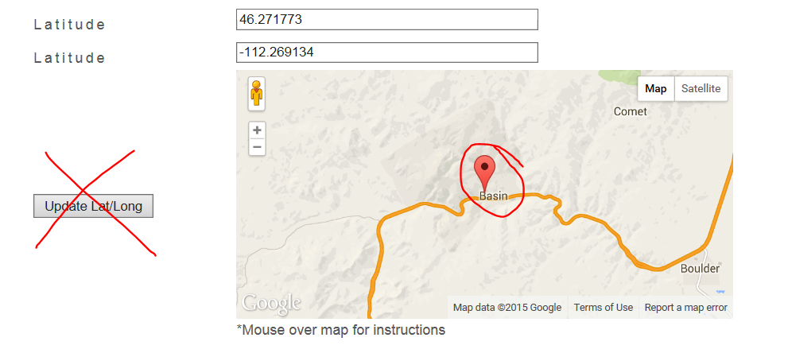

Towards the bottom of the page there is a tool to edit/upload listing images, click on Open Image Tool:

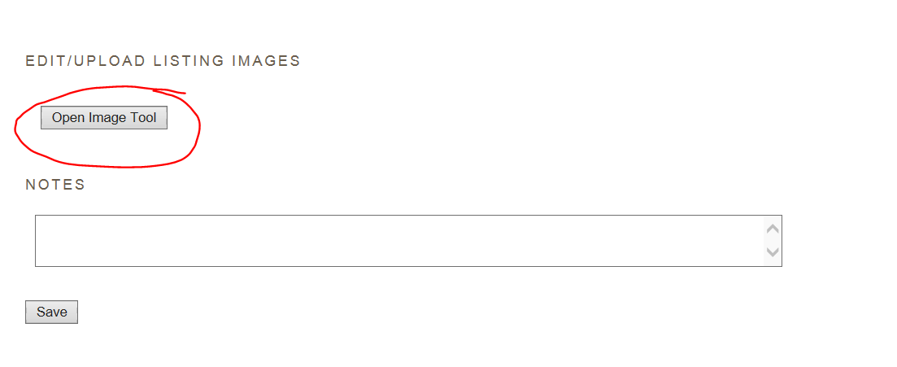
The upload image file will allow you to browse to where your images are stored on your computer and upload them to your listing. Remember the images need to be horizontal and at least 1700 pixels by 1100 pixels.
Once you have browsed to your image hit the upload selected images:
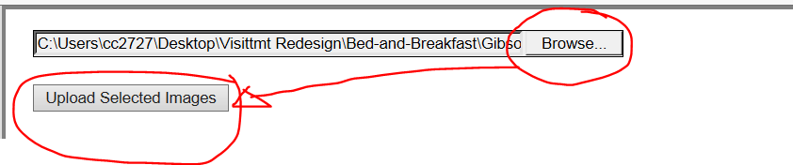
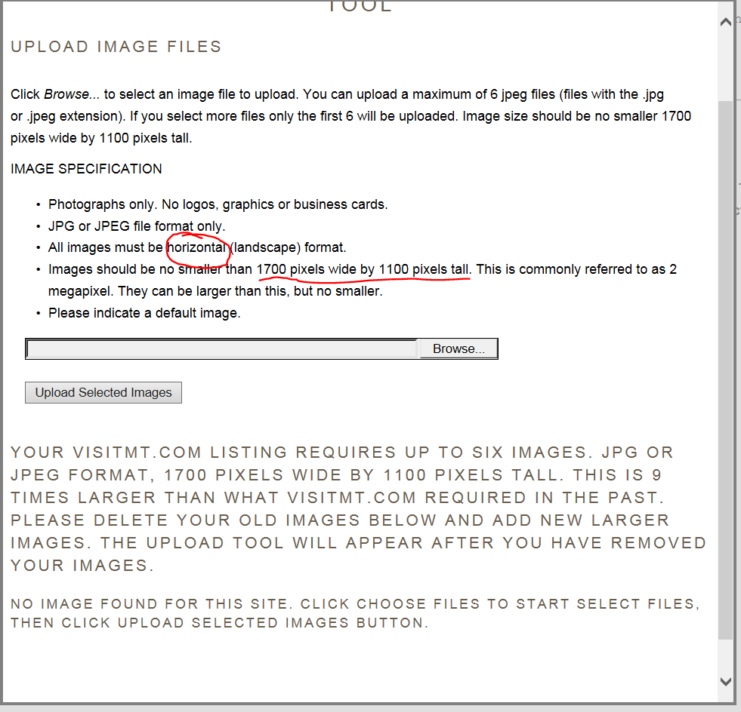

If you do not see a thumbnail image of an image that you have attempted to upload but instead see red text message reminding you that the size must be at least 1700 pixels by 1100 pixels that means your image did not upload and you will have to find a larger image.
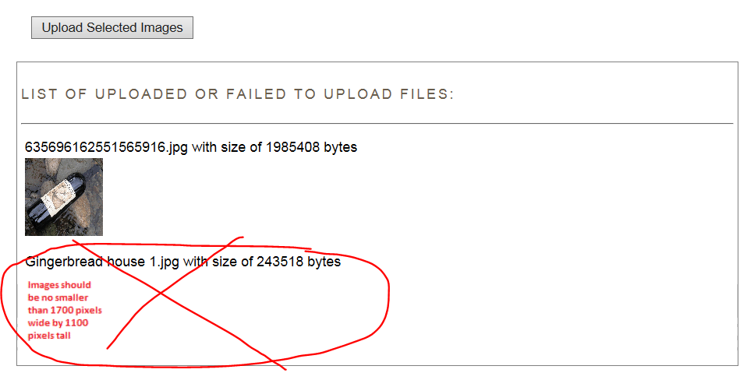

When you are done uploading images, click on the Finish button at the bottom of the image tool:
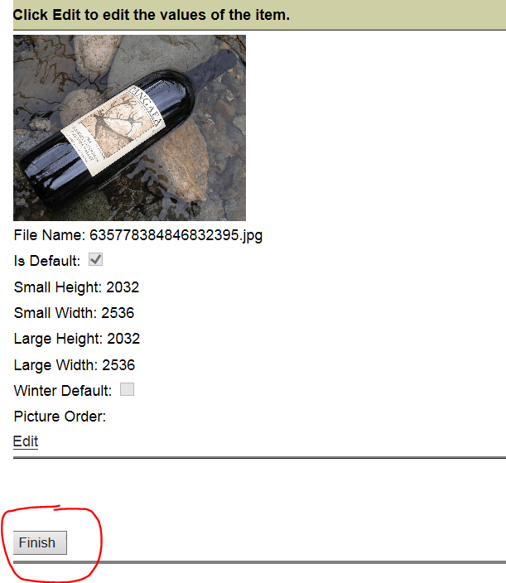
And you need to click on the Save button on the main page to save all the changes in the image tool as well as any other changes you have made.

The first picture added will automatically be your default image. But if you would like to change the default or remove an existing image go back to the image tool
And click on word “Edit” below the thumb image:
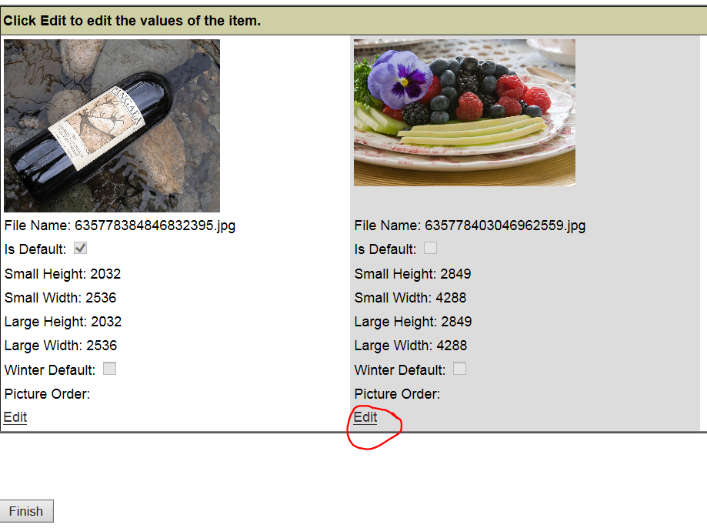

The image will turn yellow and you can either make the image the default by clicking on the words default or delete by clicking on the words delete
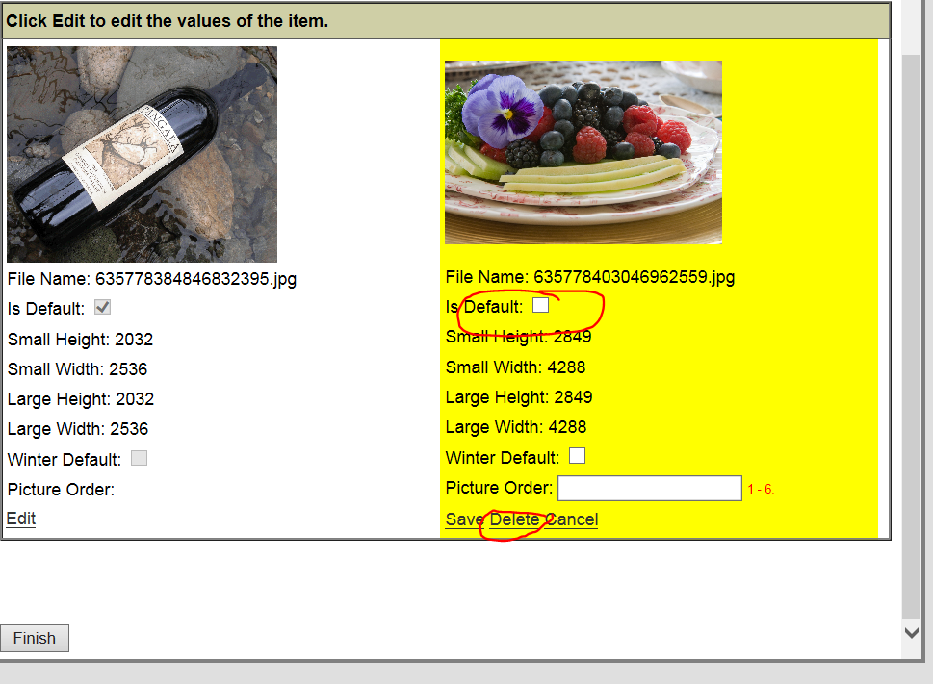

In this case, I want to make the image the default, I select Is Default and hit the save button:
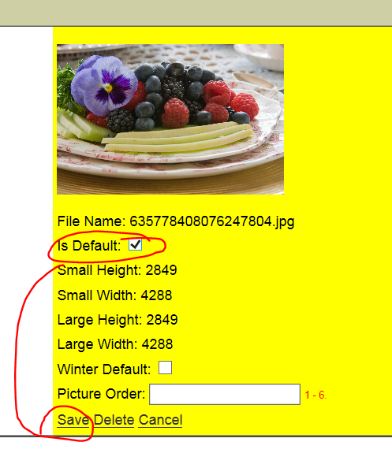
I still will have to hit the finish button in the image tool.

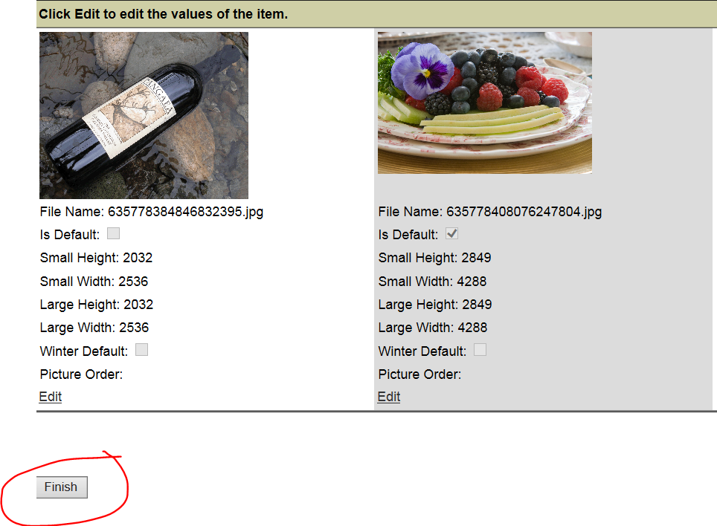
And then the save button at the bottom of the main page:

You will see a tag on your listing that says your listing changes are now waiting for approval:
