- Forgot Password

From http://business.visitmt.com select Log In
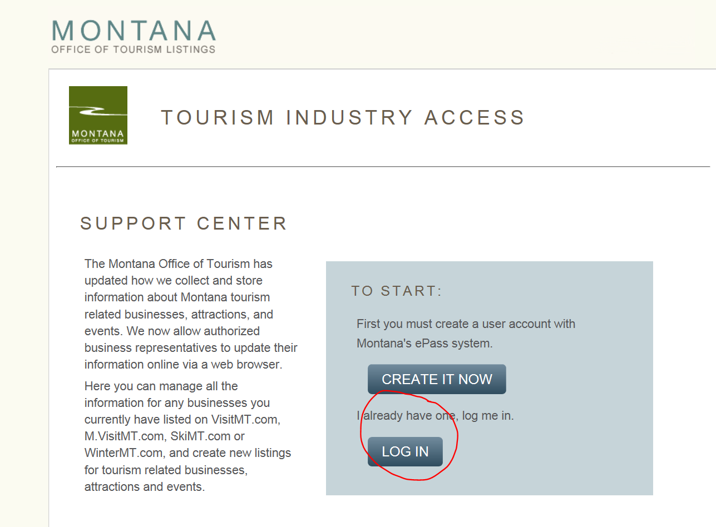

Which will take you to the Montana e-pass system. Select the Feedback Tab:
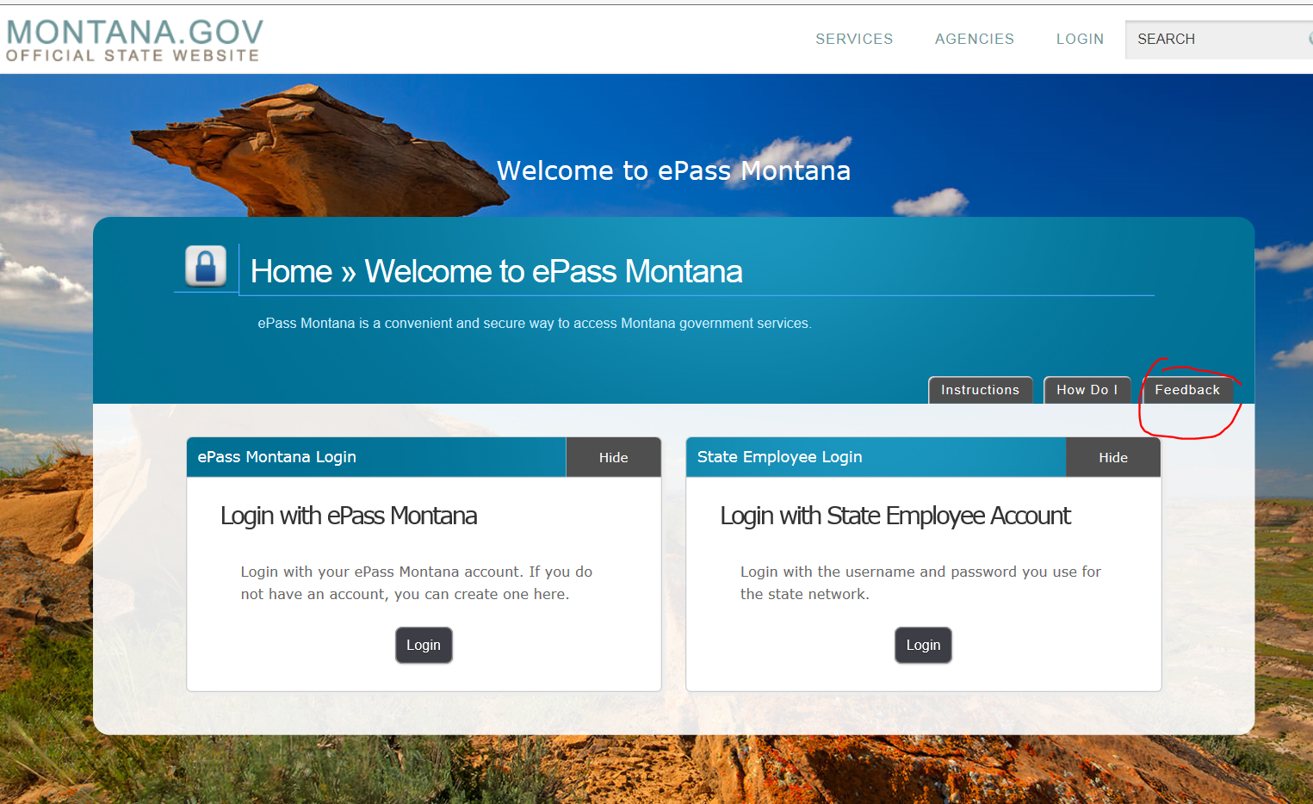

Select “I am having a problem”
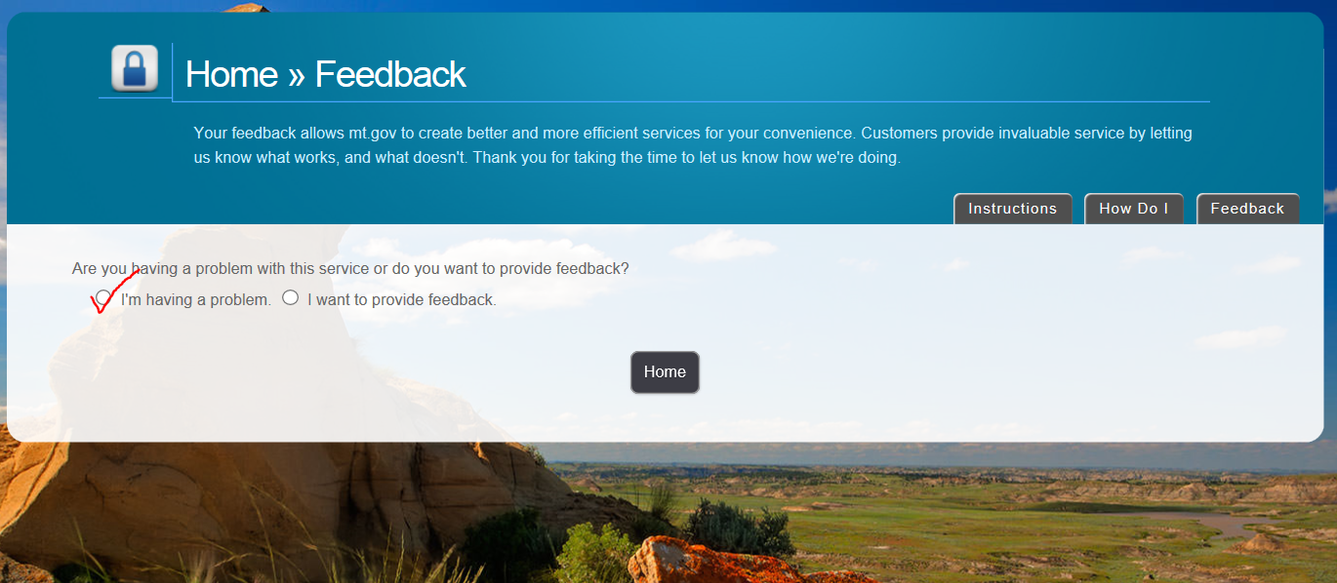

This opens the link to the contact page; click on Contact Us
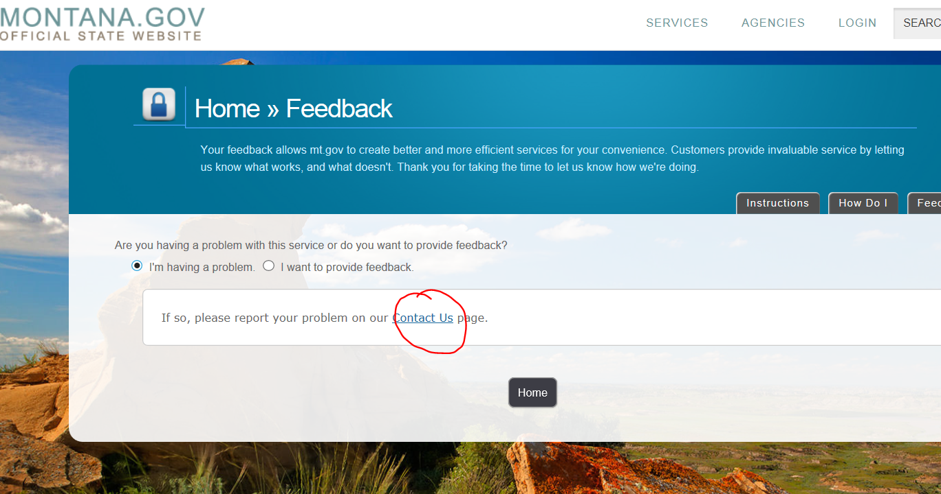

This brings you to a page with several different ways to contact the Help Desk including calling and email
