Webgrants New User Registration
Login to https://funding.mt.gov/index.do
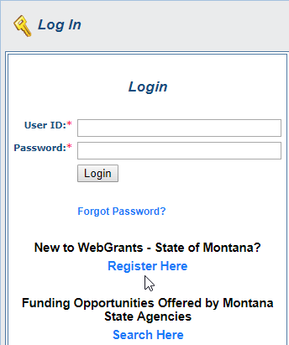
Click ‘Register Here’

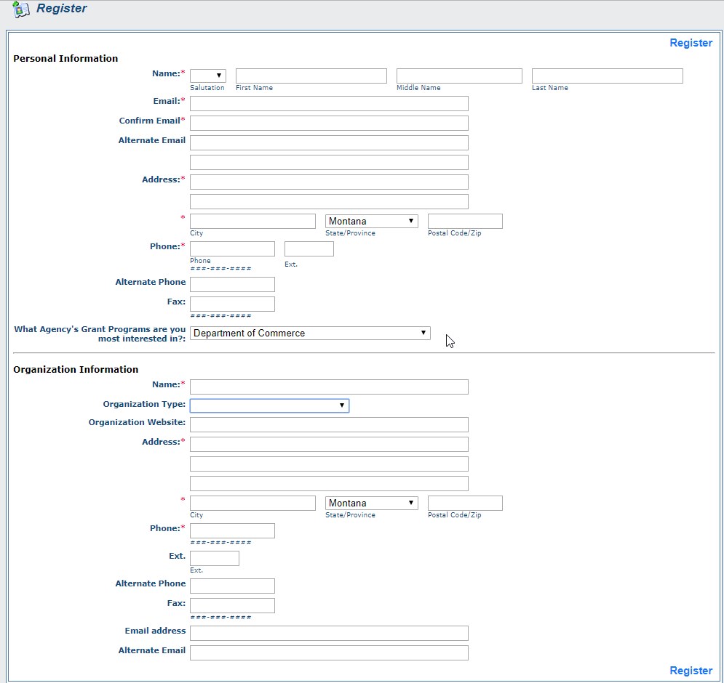
Provide information for all the required fields (*)
The form asks for personal information – use business information

Choose Department of Commerce for Agency Grant Programs

Click the ‘I’m not a robot’ box

Click ‘Register’

Once Registered you will receive an email confirming your registration.
A second email will be sent once your registration is approved.
Change your password when you log in https://funding.mt.gov/index.do

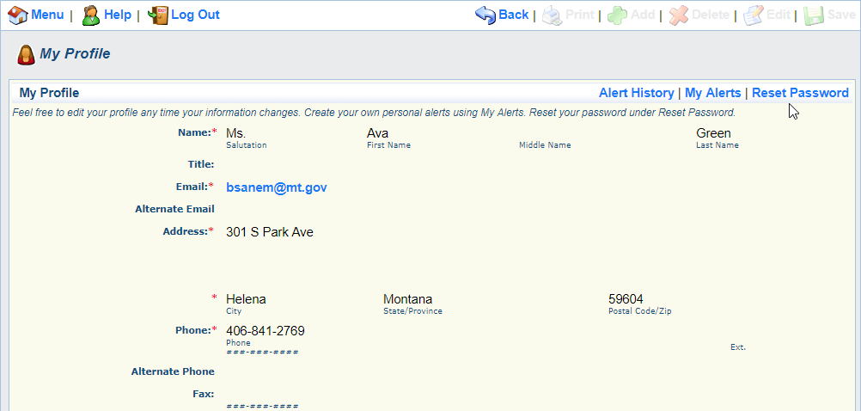

Contact Barb Sanem if you have questions. bsanem@mt.gov or 406.841.2769

