Region/CVB Travel Reimbursement Form Instructions

(1) (2) (3) (4) (5) (6) (7) (8) (9) (10) (11) (12) (13)
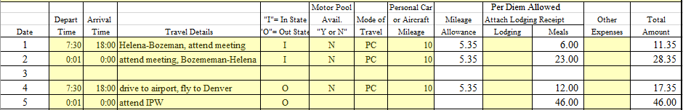

- Date – manually enter required travel information to the right of the date traveled. Columns are numbered 1-31 to represent each day of the month.
- Depart Time – manually input time travel began HH:MM. Military time must be entered for form to calculate allowable meal per diems. On each date that you have spent the night manually input 0:01 for Depart Time. (see Date line 2)
- Arrival Time – manually input time travel ended HH:MM. Military time must be entered for form to calculate allowable meal per diems. On each date that you spend the night manually input 24:00 for Arrival Time. (see Date line 2)
- Travel Details – manually input details of travel for that day. Were you traveling, attending meeting or conference, etc.?
- ‘I’ = In State, ‘O’ = Out State – manually input ‘I’ if you are traveling within the state or ‘O’ if you are traveling out of state. ‘I’ or ‘O’ must be entered for form to calculate allowable meal per diems.
- Motor Pool Available – manually enter ‘N’ (no). ‘N’ must be entered for form to calculate allowable mileage per diem.
- Mode of Travel – manually enter ‘PC’ (personal car) if mileage reimbursement is being made for personal use of vehicle for business travel. ‘PC’ must be entered for form to calculate allowable mileage per diem.
- Personal Car or Aircraft Mileage – manually enter the number of miles traveled each day. Number of miles traveled that day must be entered for form to calculate allowable mileage per diem.
- Mileage Allowance – the form will automatically calculate and fill in the Mileage Allowance based on information provided in the Motor Pool Avail (6), Mode of Travel (7) and Personal Car Mileage (8) columns.
- Lodging – manually enter total cost of room charge + tax and any other fees that are included as part of the daily room charge. The expectation is that in-state lodging will be booked at the current state rate. https://www.gsa.gov/portal/category/100120
- Meals – the form will automatically calculate and fill in the Meal Per Diem Allowed based on information provided in Depart/Arrival Times (2 & 3) and in/Out of State (5) columns.
- Other Expenses – manually input allowable other expenses not included as part of the Mileage or Meal Per Diem Allowed. Examples of other expenses may include baggage fees, rental car cost, etc.
- Total Amount – total amount of daily travel expense. Includes Mileage Allowance, Lodging, Meals and Other Expenses

Additional Information

Only yellow highlighted cells allow input.
Do not copy or cut/paste information in yellow highlighted cells

- #VALUE! message in Meals column

Depart Time and Arrival Time columns– enter military time
In State/Out State column – enter ‘I’ or ‘O’

- Mileage Allowance column is blank

Motor Pool Avail column – enter ‘N’
Mode of Travel column – enter ‘PC’
- Other Expenses
Invoice for each eligible expense being reimbursed must be attached
- Required personal information for reimbursement
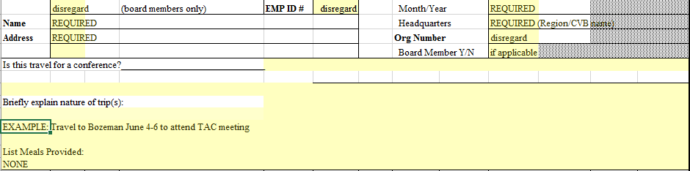
- Itemization of State Credit Card – Disregard this section
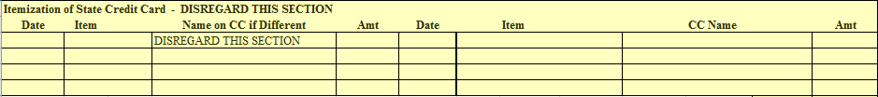

If ANY meals are provided, use the exception travel form. Manually enter Meal Per Diems Allowed.

If you have any questions contact Barb Sanem 406.841.2769, bsanem@mt.gov
http://marketmt.com/TourismRegionsCVBs

